Acknowledgements

WHAT has been funded in part by:

CRSNG through a Ph.D. scholarship to Jean-S´ebastien Gosselin
Projet Mont´er´egie Est PACES
CRSNG funds (tu veux dire du côté de Richard pour ta 4e année?)
Geological Survey of Canada
We would like to thank all people who have used WHAT since its earliest stages and provided essential technical feedback, constructive criticism, and helpful comments or have helped in the shaping of the science that lies under the hood of the software. In particular, special thanks to (in alphabetical order):

Erwan Gloaguen, Professor in? Applied Geophysics and Geostatistics, INRS-ETE, Québec, QC, Canada.
Harold Vigneault, Research Professional, INRS-ETE, Québec, QC, Canada.
Marc Laurencelle, Ph.D. Student in Earth Sciences, INRS-ETE, Québec, QC, Canada. Pierre Ladev`eze, Ph.D. Student in Earth Sciences, INRS-ETE, Québec, QC, Canada. Ren´e Lefebvre, Professor in Hydrogeology, INRS-ETE, Québec, QC, Canada.
Xavier Malet, Research Technician, Geological Survey of Canada – Québec Division, QC, Canada.

Foreword

WHAT started originally as a little piece of code to fill missing climate data and create automatic graphs turned out into a 10 000 line code that allows the user to:
- Download Environment Canada climate data on a daily basis for any given period;
- Fill out missing climate data using different options;
- Generate graphs showing daily climate data and hydrographs that can be easily looked at over different time scales;
- Assess a recharge rate based on a well hydrograph and a basic water budget to estimate the specific yield.
This document is divided in two parts: the User’s? Manual and the Technical Documentation.
The first part, User’s Manual, contains all the information relative to the practical? use of the software, such as how to define the “Projects”, how to prepare the water-level dataset and how to make the best use of barometric measurements. The Technical Documentation part contains a literature review, as well as mathematics and theoretical concepts behind the development of the tools included in WHAT. This part also contains all the information that is related to programming. The entire code is presented in a flowchart, which also illustrates the structure and organization of the source files.

List of Figures
  - WHAT GUI main features. 10
  - Screenshots of WHAT GUI tabs captured in Ubuntu Linux 14.04. 11
  - WHAT workflow. 12
  - New Project dialog window. 15
  - Project folder file organization. 16
  - Tab ‘‘Download Data’’. 17
  - Graphical interface to the online CDCD database. 18
  - Tab ‘‘Fill Data’’. 20
4.1 Mode ‘‘Computation’’ of the Tab ‘‘Hydrograph’’. 22
5.1 Mode ‘‘Layout’’ of the Tab ‘‘Hydrograph’’ 27
7.2 Typical instrument configuration for water level monitoring in an observation well . 35 8.1 WHAT workflow. 40
8.2 Locations of the weather stations in the Monteregie Est area 45
  - Weather Station List (*.lst) Sample 51
  - Creation of a custom weather station list how-to 52
  - Locations of the observation wells and the weather stations in the Monteregie Est area. 54
  - Typical hydrographs relating to the three classes that were considered in the analysis of the confinement conditions of the regional bedrock aquifer in the Monteregie Est
area, Quebec, Canada. 55
  - Confinement conditions deducted from the well hydrographs compared to the map
of confinement conditions of the regional bedrock aquifer. 56

Contents

I User Manual 7

Introduction 8
  - What is WHAT 8
  - Installation 9
  - Overview of the Graphical User Interface 9
  - Workflow for Interpreting Water-level Time-series 11

Projects Management in WHAT 14
  - Introduction 14
  - Create a New Project 14
  - Open a Project 15
  - Project Folder Structure Overview 15

Gapless weather data series creation 17
  - Downloading and formatting data from the CDCD 17
    - Searching for Stations 18
    - Downloading Data 18
    - Formatting Data 19
  - Gap filling daily weather records 19
  - Using weather data from other sources 21

Water-level time-series preparation 22
  - Water Level Format 22
  - Well Configuration and Location Information 23
  - Manual Measurements 24
  - Loading the data and Computation mode overview 24
  - Water Level Corrections 25
    - Aberrant values 25
    - Hung-depth corrections 25
    - Datum correction 26

Plotting the data 27
  - Hydrograph Overview 28
  - Toolbar 28
  - Right Panel 29
  - Water Level Datum 29
- Water-level time-series interpretation 31
  - Barometric response function 31
  - Estimation of the MRC and first recharge estimation 31
  - Recharge estimation with synthetic well hydrograph method 31
II Technical Documentation 32
- Water-level measurements in Well and Piezometers 33
  - Barometric correction: an overview 33
  - What can I do in case of equipment failure 33
    - Format des donn´ees brutes 34
- Estimation of missing daily climatological data 37
  - Introduction 37
  - Literature review 37
  - Description of the method 38
    - Step 1: Pre-processing 39
    - Step 2: Filling the Gaps 41
    - Step 3: Validation 42
  - Monteregie Est Case Study 43
    - Materials and Method 43
    - Results and Discussion 46
  - Future Work 46
- MRC Estimation 47
  - Local Extremum Search 47
  - Parameter Optimization 48
- Well Barometric Response Function 49
III Appendices 50
- Creating a Custom CDCD Weather Station List 51
- Hydrogeological characterization of the regional bedrock aquifer confinement conditions in Monteregie Est 53
  - methodology 53
  - Results 53
  - Conclusion 58

Part I User’s? Manual

- Introduction

  - What is WHAT
WHAT (Well Hydrograph Analysis Toolbox) is a free, open source, and cross-platform interactive computer program whose main focus is the interpretation of observation well hydrographs. It allows the user to:
    - prepare a gapless daily weather time-series (total precipitation and air temperature) that is representative of the well location. For this purpose, an interface to the online Canadian Daily Climate Database (CDCD) was created to query the stations interactively by
geographical coordinates. The available data are then downloaded and automatically rearranged in a format compatible with WHAT. Furthermore, missing data for a given station may be quickly filled with data from selected neighboring weather stations using a multiple linear regression model;
    - generate various publication-quality graphs from the weather and water level datasets over different time scales;
    - explore, manipulate, and validate the data within a user-friendly dynamic graphical environment;
    - calculate the master recession curve of the experimental well hydrograph;
    - estimate groundwater recharge with a method combining daily meteorological data to better estimate the specific yield and the water-level time series. Therefore, this method can only provide a recharge assessment at the local scale and for unconfined conditions.
    - assess the level of confinement of the aquifer at the well location using the KGS BRF program (Bohling et al., 2011; Butler Jr. et al., 2011) that allows the calculation of the barometric response function of the well.

WHAT is written in the Python 2.7 programming language and is currently maintained and developed by Jean-S´ebastien Gosselin at INRS-ETE (www.ete.inrs.ca). The source code and a stand-alone executable for Windows 7 are available free of charge for download on GitHub (https://github.com/jnsebgosselin/WHAT). If you encounter any problems or errors during program execution, have any questions, or have suggestions on how to improve WHAT, please contact Jean-S´ebastien Gosselin at this email address: jnsebgosselin@gmail.com.
  - Installation
WHAT can (is able to?) run on Windows, Linux, or OS X computer operating systems. However, a stand-alone executable of the program is currently released and tested only for the Windows 7 platform. This executable should also be compatible with Windows XP. For the Linux and OS X platforms, the software can be run directly from the source code, provided that Python 2.7 and all the required third party packages are installed on the computer (PySide, NumPy, matplotlib, xlrd, xlwt).
The stand-alone executable for Windows 7 is distributed in a Zip archive that can be downloaded freely on GitHub (https://github.com/jnsebgosselin/WHAT/releases). This archive contains:
    - the GNU General Public License;
    - a folder named ‘‘WHAT’’ that contains all the necessary system files for the program to run, including the file ‘‘WHAT.exe’’ from which the software can be started (executed?);
    - a folder named ‘‘Projects’’ where all input and output files used or created by WHAT are stored by default. This folder includes samples of input and output files that provide a quick and convenient way to test and learn the various features of the program.

Once the content of the Zip archive has been extracted, the program can be started directly from the WHAT.exe executable file that is contained within the folder named WHAT. The software can conveniently run from any location on the computer or from any storage device without the need to install the program beforehand.

  - Overview of the Graphical User Interface (GUI)
WHAT Graphical User Interface (GUI) mainly consists of a menu bar, a console area, and a central view panel (see Figure 1.1). The menu bar is located in the top right corner of WHAT main window. This is where you can view the name of? the current project, open an already existing project or create a new one. The console is located at the bottom of the WHAT interface and is used to report technical information about the various tasks accomplished by the program, as well as warning and error messages. The console can be collapsed to save space, or can be extended to the entire window area. The central view panel is the main component of the WHAT interface and is where the various features of the software are displayed. The content of this panel is divided into four tabs: Download Data, Fill Data, Well? Hydrograph, and About. These tabs are described in more details below and are shown in Figure 1.2.

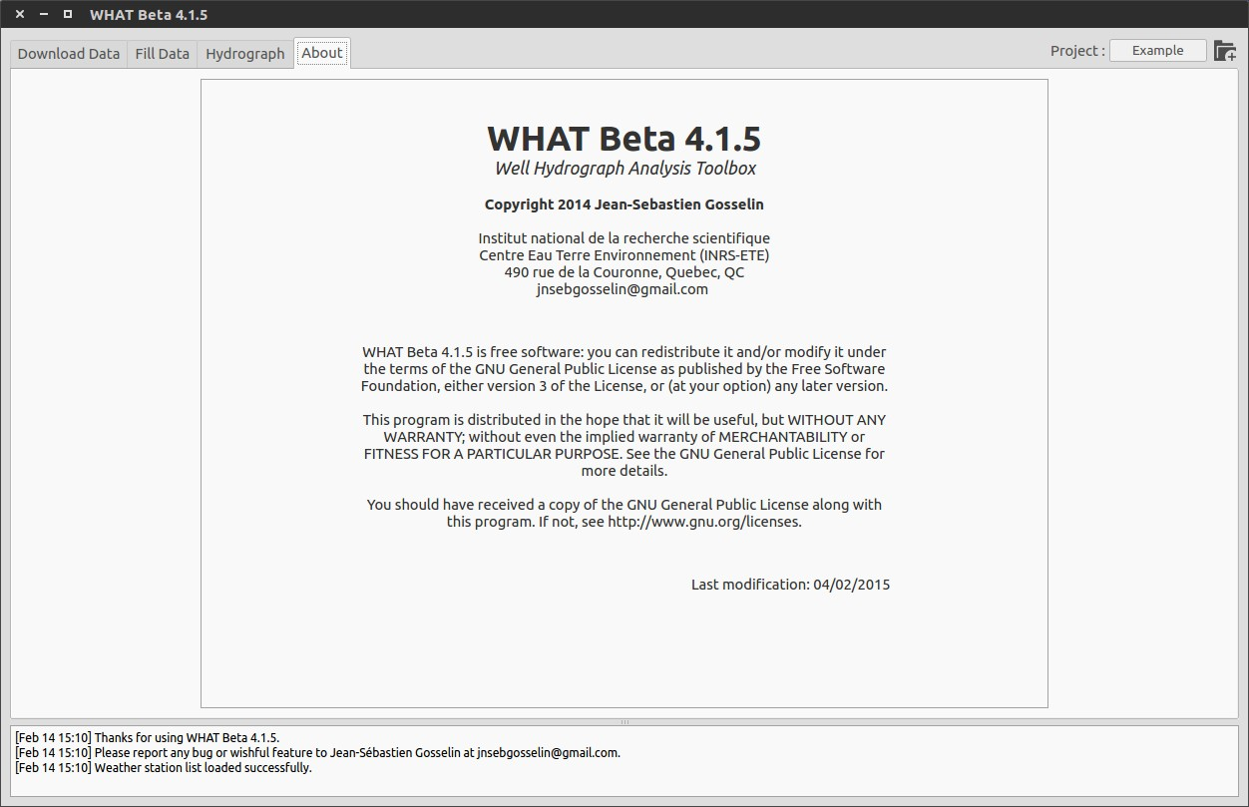

Figure 1.1: WHAT GUI (Graphical User Interface) main features.

Download Data: This tab (Figure 1.2a) provides an interface to the online Canadian Daily Climate Database (CDCD), owned and operated by Environment Canada, that allows the interactive query of stations by location coordinates, the download of available data, and the automatic rearrangement of the data in a format compatible with WHAT. Alternately, it is possible to provide a custom list of Canadian weather stations for which data can be downloaded and formatted. At the moment, it is not possible to access data of weather stations located in the U.S. This feature may be added in a future release of the software.

Fill Data: This tab (Figure 1.2b) is where you can automatically estimate the missing daily weather values in your dataset to create gapless time-series of daily precipitation and air temperature. Missing data for a given station are estimated from selected neighboring weather stations using a multiple linear regression model. Filled data are not subsequently used to fill other gaps.???

Well? Hydrograph: This tab is used for viewing and plotting both groundwater-level and weather data to better interpret the studied well. For this purpose, two modes are available: the layout and the computation mode. Both modes share the same weather and water-level datasets and it is possible to switch from one mode to the other at any time. The layout mode (Figure 1.2c) provides an interface to interactively produce publication-quality graphs. The computation mode (Figure 1.2d) consists in a dynamic graphical environment where data can be explored (looked at? invertigated?), manipulated and analyzed over different time scales. Various computational tools are available in this mode, including the estimation of the hydrograph Master Recession Curve (MRC) and the estimation of groundwater recharge.

About: This tab (see Figure 1.1) displays copyright, licensing and general information about WHAT.

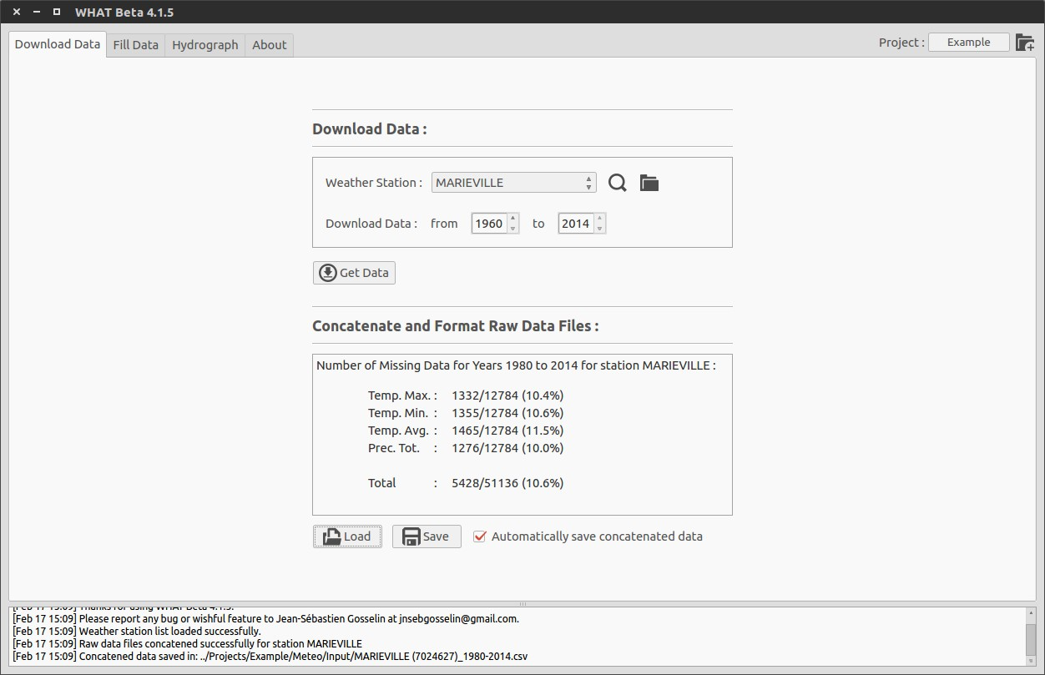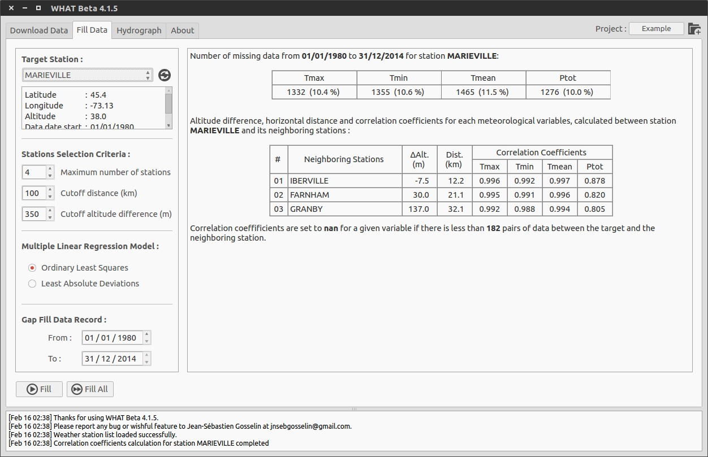
(a) ‘‘Download Data’’ tab. (b) ‘‘Fill Data” tab.

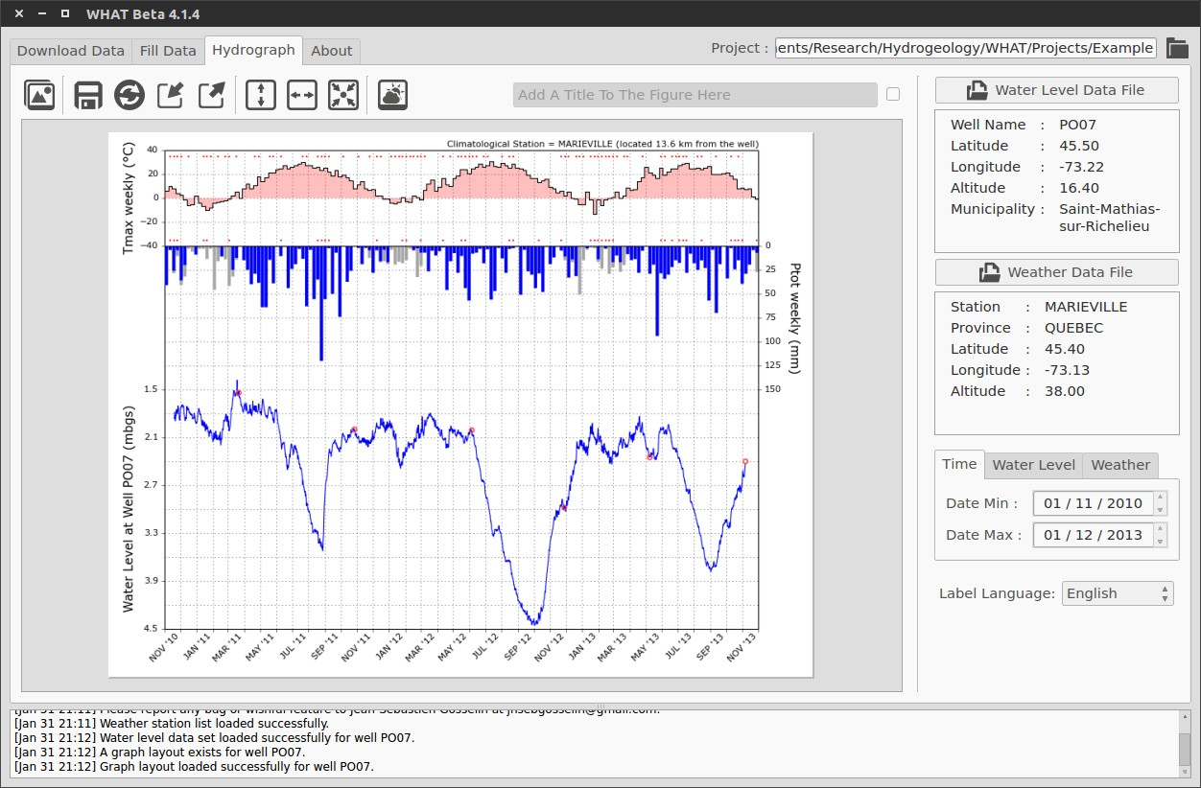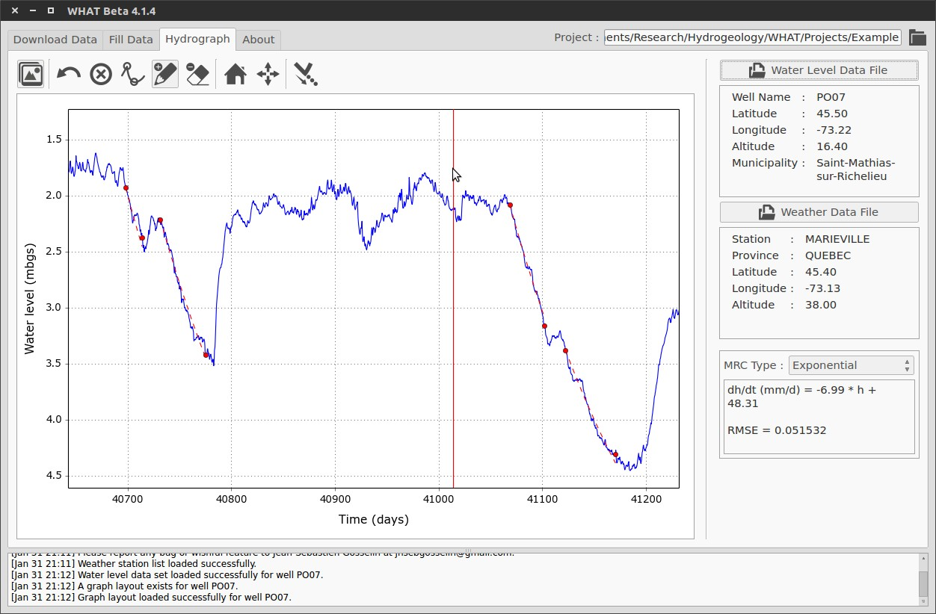
(c) ‘‘Well? Hydrograph’’ tab in ‘‘Layout’’ mode. (d) ‘‘Hydrograph’’ tab in ‘‘Computation’’ mode.

Figure 1.2: Screenshots of WHAT GUI tabs captured in Ubuntu Linux 14.04 showing an example of project. (a) ‘‘Download Data’’ tab. (b) ‘‘Fill’ Data” tab (c) ‘‘Well? Hydrograph’’ tab in ‘‘Layout’’ mode. (d) ‘‘Hydrograph’’ tab in ‘‘Computation’’ mode.

  - Workflow for Interpreting Water-Level Time-Series
WHAT is a computer software that brings together a set of tools to conveniently? assist in the interpretation of water-level time-series, from the download and processing of raw data to the assessment of groundwater recharge from a well hydrograph. Some of the tools included in WHAT use well known and documented techniques, such as for the estimation of missing daily weather values that employs a multiple regression model. Others are genuine improvements of poorly known or used method, such as for the estimation of groundwater recharge that uses an approach based on the fitting of a synthetic hydrograph to groundwater-level measurements. Furthermore, WHAT has been designed from the start to be modular, so that it will be very easy to add more tools in the future to expand the possibilities of this software.
The strength of WHAT lies not only in its various tools, but in the integration of these into a complete functional workflow for the interpretation of water-level time-series. This workflow is presented in Figure 1.3. By providing a unique centralized environment where data can be processed, explored and analyzed, a lot of data manipulation and time can be saved. Moreover, the interpretation of the data is greatly facilitated due to the implementation of a dynamical graphical environment. This is a significant improvement over fragmented tools, some of which consisting of a simple generic spreadsheet that is not well suited for the dynamical exploration of time series.

Search for Weather Station in CDCD*
New Raw Water Level Dataset

Download and Format Weather Data
Correction

Removal of Erroneous Measures
Fill Gaps in the Dataset using the Stations Closest
to the Well

Hung-Depth Corrections

Plot Hydrograph, T and Ptot?

Datum and Drift ??? Il peut y avoir une dérive”? Corrections

Compute Barometric Response Function
YES
Water Level Sampling Rate at Least Hourly?

NO

Is Aquifer NO

Interpretation Completed
Unconﬁned?

YES

Estimate MRC**

* CDCD = Canadian Daily Climate Database? Sinon pourquoi deux fois “CD »?

Estimate Groundwater Recharge

Interpretation Completed

** MRC = Master Recession Curve

Figure 1.3: WHAT workflow for the interpretation of groundwater-level time-series measured in an observation well or a piezometer. Quand tu utilises des losanges, c’est que tu poses une question?
The workflow shown in Figure 1.3 represents the different steps for the interpretation of data collected at a single well. However, WHAT is also well suited for the study of multiple wells located in a large study area, such as what is needed for regional characterization projects. More specifically, the WHAT software allows you? 1) to navigate easily among? the different water-level and weather datasets of a given study area, 2) to make straightforward? comparisons of the different datasets through the use of automatic graph production ,3) to efficiently analyze hydrographs using key weather data to better determine (evaluate?) the hydrogeological context and 4) to assess aquifer recharge based on the combination of data from a well hydrograph and a basic water budget providing a robust estimate of the specific yield parameter (Sy) . This can represent a substantial gain in time and data manipulation when the number of wells for a given study area is large and when there is a need to update the datasets regularly during the project. Details about the management of “projects” within WHAT is presented in Section 2.
The first Step in the proposed workflow (Figure 1.3) for the interpretation of water-level time series consists in the preparation of gapless weather datasets. This includes downloading and formatting weather data from the CDCD (Canadian daily climate database) database (lien internet?) and estimating the missing daily values within each record by using data from selected neighboring stations. This step is discussed in details in Section 3. The second step corresponds to the processing of the water-level time series, including the validation and correction of the data. This is covered in details in Section 4.
Once the weather and water-level time series have been prepared, the next step (Step 3) consists in the production of the well hydrograph. This topic is covered in Section 5. The plotting of water-level and weather data time-series is an important step in the interpretation process that should not be overlooked since it can provide meaningful insights on the confinement conditions of the aquifer at the local and regional scale. For example, Appendix B presents an application where well hydrographs produced with an early version of WHAT were used to infer the confinement conditions of the regional bedrock aquifer in Montéregie Est(∼9000 km2) located in southern Quebec, Canada (Carrier et al., 2013). Results from this qualitative analysis showed good agreement with the map of confinement conditions of the regional bedrock aquifer which was based on the sequence and thickness of the surficial deposits.
After the production of the corrected? well hydrograph, Step 4 consists in estimating the barometric response function of the well, given the water-level and barometric measurements were acquired at a sufficient sampling rate(Butler Jr. et al., 2011; Rasmussen and Crawford, 1997; Spane, 2002). This tool is very useful as it provides additional information to better characterize the confinement conditions of the aquifer around the well. WHAT also gives valuable insights on? the transmissivity of the well. This approach is discussed in Section 10 and an example of an application in the Monteregie Est area is presented in Appendix C. based on a poster presentation by Gosselin et al. Using the drilling log of the well, the hydrograph and the barometric response function, it should be possible to determine with a good degree of confidence if the well is under confined or unconfined conditions. For the latter case, the water-level and weather data time-series can be used jointly to assess the aquifer recharge in Step 5. The first task of this step consists in the estimation of the hydrograph Master Recession Curve (MRC). Aquifer recharge is then estimated as the residual of a daily soil moisture balance (DSMB) model and the resulting fluxes are substituted into a mathematical model of the aquifer groundwater balance to produce a synthetic well hydrograph. The last task consists in the calibration of the DSMB model parameters, based on the comparison of the synthetic and observed well hydrographs to get a robust estimate of the specific yield (Sy). An example of groundwater recharge assessment is presented in Appendix D for a well located in Rougemont in the Montéregie Est area.

- Data Management by Projects in WHAT

  - Introduction
Data is managed in WHAT by project. This includes all input and output files relative to a given project are saved within a common folder called ‘‘project folder’’. This file management system allows you to easily travel from one step to the other backup and move your projects from one location to the other since all the files related to a given project are saved at the same place.
When you first launch WHAT, the software will automatically open an example with all the necessary files that allows you to easily and quickly test the different functionalities of the program. The title of the current project is shown in the menu bar at the top of the page?. Additional information about the project can be displayed by clicking on the small ‘‘i’’ icon located next to the project name. Only one project at a time can be open in WHAT.

  - Create a New Project
To start a new project, click on the button New Project or click on the small folder icon located at the right end of the WHAT menu bar (see Figure 1.1). This will open a new dialog window (see Figure 2.1) where you can enter information about your project such as its title, author and location coordinates.
Clicking on the button Save creates a new project folder named after your project title. Your project information is saved in a file having a ‘‘.what’’ extension. The new folder is created at the location defined by the Save in Folder directory path. For example, saving the My New Project by John Doe (Figure 2.1) would create a folder named ‘‘My New Project’’ in the directory ‘‘C://Users/johndoe/WHAT 4.0.5-beta/Projects’’ and would save the project information in the file named ‘‘My New Project.what’’. It is possible to change the directory where the project folder is created by clicking the small folder icon located next to the Save in Folder directory path.

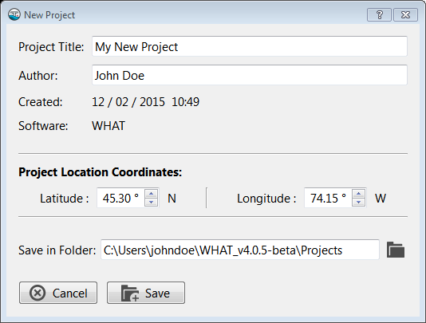

Figure 2.1: New Project dialog window.

  - Open a Project
To open an existing? project, click on the icon located in the top right corner of the WHAT window. This will open a new dialog window where you can browse your folders to select an existing project file (*.what), and then click Open. WHAT will then open the project and the displayed project name appearing in the menu bar will change for the name of the project you just selected.
The path to your project folder is stored in WHAT in a relative format. This means that if you change the location of your project folder relative the ‘‘WHAT.exe’’, your will have to redirect WHAT to the new location of your project by repeating the procedure described in the paragraph above.

  - Project Folder Structure Overview
In addition to the project file (.what file extension) that is created when saving a new project, WHAT automatically generates various files and sub-folders that are required for its execution. This file organization is briefly described below and an example is presented in Figure 2.2. The project folder contains two sub-folders named ‘‘Meteo’’ and ‘‘Waterlvl’’ and a few other files.

Meteo: The sub-folder Meteo contains three sub-?sub-folders named respectively Raw, Input and Output. The binder Raw is where the weather data files downloaded from the CDCD are saved. CDCD files contain daily weather data for a given year, each separated with a coma (CSV) for a given year. All the data files for the selected years for a given weather station are saved in WHAT within a common folder named after the station name and its unique identification number (IDN). For example, in Figure 2.2, the raw data file ‘‘eng-daily- 01011980-12311980.csv’’ that contains weather data of the station ‘‘Marieville’’ for the year 1980 is saved within a folder named ‘‘MARIEVILLE (7024627)’’ where the number in parentheses corresponds to the station IDN.
The binder Input contains the formatted weather data files produced from the raw data files, for the selected years of a given station.
These are tab-separated values (TSV) files that are named after the station’s name and IDN.
The binder Output is where the gapless weather time-series are saved. Files are produced using the content of the Input folder and a gap-filling procedure. They are saved in TSV text files with the extension ‘‘.out’’. The files with the extension ‘‘.log’’ are TSV text files that contain detailed information about every missing daily weather value that was estimated by the program to produce the gapless time-series (*.out files).

Waterlvl: The sub-folder ‘‘Waterlvl’’ is the preferred location where your water-level time-series should be stored. These files can be either in a Microsoft Excel spreadsheet file format (xls) or in a tab-separated values text format (TSV).

Other Files: The file ‘‘weather stations.lst’’ is a resource file that is used to store the results of a weather station search in the Canadian Daily Climate Database (CDCD). The file ‘‘graph layout.lst’’ is also a resource file in which are stored the layout parameters of the well hydrographs that are produced in the hydrograph tab of WHAT. The file ‘‘weather datasets summary.log’’ is a tab-separated values (TSV) file that contains a summary of all the weather data files included in the ‘‘Input’’ folder. The file ‘‘waterlvl manual measurements.xls’’ contains all the available manual water-level measurements from field visits. These values can be added to graphs showing the well hydrograph and hence, they can be used to check and adjust the position of the water-level time-series on the vertical axis when the depth at which the pressure probe was installed in the well is unknown.


▼My New Project
My_New_Project.what Mettre des majuscules?
weather_stations.lst
graph_layout.lst weather_datasets_summary.log
waterlvl_manual_measurements.xls
▼Meteo
▼

▼

▼
▼
Raw
▼MARIEVILLE (7024627)
eng-daily-01011980-12311980.csv
Input
MARIEVILLE (7024627)_1980-2014.csv
Output
MARIEVILLE (7024627)_1980-2014.log MARIEVILLE (7024627)_1980-2014.out
Waterlvl
PO01.xls

Figure 2.2: Project folder file organization.

- Creation of Gapless weather data series

  - Downloading and formatting data from the CDCD
The Canadian Daily Climate Database (CDCD) contains daily air temperature and precipitation dating back to 1840 for some of the stations to the present for about 8450 stations distributed across Canada. Data can be downloaded manually on the Government of Canada website (mettre le lien) as CSV files on a yearly basis, or it is possible to acquire the entire database by ordering a DVD. The former option involves a lot of repetitive manipulations and can quickly become a time consuming task while the DVD option has the disadvantage of only providing an image in time as data cannot be updated. Moreover, the re-organization of the individual yearly CDCD data files in a more convenient format for a given station can also represent a tedious task when done manually.
WHAT alleviates this process by providing a user-friendly? interface to the online CDCD database that allows you to 1) query stations interactively using geographical coordinates, 2) download the available data according to the selected dates and 3) automatically rearrange the data in a format compatible with WHAT. All of these features are available from the Download Data tab shown in Figure 3.1.

Figure 3.1: Tab ‘‘Download Data’’.
    - Searching for Stations
To start searching for weather stations in the online CDCD, go in the Download Data tab and click on the small magnifying glass icon located next to the Weather Station drop down list, which should be empty if you have just created a new project. This will open a new dialog window (see Figure 3.2) where you can search for stations located within a given radius around a geographical coordinate defined in latitude and longitude in decimal degrees. It is possible to further narrow down the search by including only stations that have data within a given period.
Clicking on the button Search initiates the search for weather stations with the specified parameters. The results are saved in the ‘‘‘weather stations.lst’’ file and the Weather Station drop down list is updated to list all the stations found during the search.

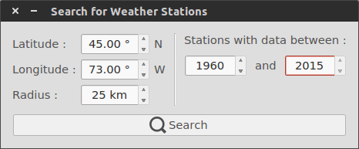
Figure 3.2: Graphical interface to the online CDCD database.

Alternatively, it is possible to use a custom list of Canadian stations generated manually without using the graphical interface. This is done by retrieving station information from their unique url directly on the government of Canada website (www.climate.weather.gc.ca). The information must be saved in a TSV text file with the ‘‘.lst’’ extension. The list can be loaded in WHAT by clicking on the small folder icon located next to the Weather Station drop down list. A detailed example is presented for the Marieville weather station in Appendix A.

    - Data Downloading
Once a list of weather stations has been generated in WHAT, either by an automatic search with the interface or manually, data can be downloaded from the online CDCD by selecting the desired station in the drop-down menu list and clicking on the Get Data button. WHAT will automatically download daily weather data from the CDCD for each year specified by the user in the Download Data year range and save the results as a CSV file in the Raw binder? (see section 2.4).
The downloading process can be stopped at any time by clicking on the button Get Data which will then be displaying a red stop icon. Before downloading the data for a given year, WHAT will first check if data already exist in the Raw binder. If it is the case, data for this year won’t be downloaded and the process will proceed? to the following year, otherwise data will be downloaded and saved. Detailed information about the program transactions during the downloading process are printed in the console area located at the bottom of the interface (see section 1.3).
    - Data Formatting
As soon as a downloading task successfully ends for a given weather station, WHAT automatically formats and concatenates the data. To do this, data from each annual file are put together end to end in chronological order and only data related to air temperature (mean, max and min) and total precipitation are kept. In addition, “NaN” (not a number)is entered where data are missing. Finally, statistics on the missing values in the dataset for each meteorological variable will be displayed in the Concatenated and Formatted Raw Data Files section.
By default, WHAT will automatically save the formatted data series in a single TSV file within the Input binder (see section 2.4). You can save other copies of the formatted data set anywhere on your computer by clicking on the Save button. The automatic saving of formatted data series can be disabled by unchecking the Automatically save concatenated data option. It is also possible to open previously downloaded weather data files in WHAT by clicking on the Load button and selecting the desired files in the dialog window. WHAT will then automatically format and concatenate the data and save the results automatically if the Automatically save concatenated data option is checked. Alternatively, the formatted data series can be saved by clicking on the button Save.

  - Gap filling of daily weather records
One of WHAT’s interesting utility is the automatic gap filling of daily weather data records. This feature is accessible from the Fill Data tab shown in Figure 3.3. Once a project is opened, WHAT automatically scans the content of the Input folder to verify the validity of weather data files and displays the result as a list of weather station names under the label Fill Data for Weather Station. This station list will not be refreshed automatically if new data files are added to the Input binder after the project has been opened. The button Refresh, located next to the list of stations, can be used for this purpose. Each time WHAT searches the Input binder for valid weather data files, it automatically computes statistics for the period over which data are available and for the number of missing data in the weather time-series and saves the results in the file named ‘‘weather datasets summary.log’’ (see section 2.4).
If the Input binder is not empty, selecting a station from the drop-down list will automatically initiate the computation of correlation coefficients between the data of the selected station and all of the remaining stations (herein called the neighboring stations) for the entire specified period, as well as horizontal distance and elevation differences. In addition, information about the number of missing values in the dataset of the selected weather station is also computed. The results are displayed in the view panel located on the right side of the interface. Correlation coefficients that fall below a value of 0.7 are displayed in red in the table. This is only meant as guidance for the user and has no impact on the gap filling procedure.
The process used to fill the gaps in the selected weather station datasets can be launched by clicking the Fill button located at the bottom, on the left side panel of the interface. Each missing value is estimated with a multiple linear regression (MLR) model generated with the synchronous weather time-series of the selected and neighboring stations. The routine uses data from the neighboring stations that are best correlated with the data of the selected station, up to the maximum number of stations defined by the user. For example, in Figure 3.3, the program would use neighboring stations with the best correlation coefficient values up to a maximum of 4 stations. If for a given date, all the neighboring stations have missing data synchronously with the selected station, a “NaN” value is kept in the dataset at this particular date.

Figure 3.3: ‘‘Fill Data’’ tab.

It has been demonstrated that the MLR method outperforms most of the commonly used techniques for the estimation of missing data in daily meteorological records (Eischeid et al., 2000; 1995; Xia et al., 1999). The user can choose between an Ordinary Least Squares (OLS) or a Least Absolute Deviations (LAD) criterion for the generation of the MLR model. The LAD technique is more robust to outliers than that of OLS but requires slightly? more computation time.
In general, data correlation between two stations for a given meteorological variable will generally decreases as the differences in altitude and distance increase. Therefore, it is also possible to specify a cutoff distance and a cutoff altitude difference: neighboring stations exceeding these cutoff values are excluded from the gap filling procedure. A value of 100 km for the cutoff distance and 350 m for the cutoff altitude difference are set as default values in the program, based on literature (Simolo et al., 2010; Tronci et al., 1986; Xia et al., 1999).
WHAT will fill the gaps in the dataset for the period specified by the user and automatically save the gapless daily weather time-series in a tab-separated values (TSV) text file with the extension ‘‘.out’’ within the binder Output of the sub-folder Meteo (see section 2.4). The file is named after the weather station name and its IDN and includes the specified period. For example, the resulting output file for the station named Marieville in Figure 3.3 would be ‘‘MARIEVILLE (7024627) 1980-2014.log’’. In addition, detailed information on each missing value estimated by WHAT to fill the gap in the data are saved in a file with the same name as the ‘‘.out”” file but with a ‘‘.log’’ extension. Information includes the number of stations used, station name and associated values (autre chose?).
It is also possible to run this procedure in batch mode if you want to fill the gaps in several station datasets at a time by clicking on the Fill All button. However, parameters for the gap filling process will then be the same for all stations.
Finally, you can assess the uncertainty associated to the estimated missing values with a jackknife procedure. This is an advanced feature that is in an experimental stage and thus cannot presently be activated directly from the GUI. The activation of this feature can, however, be done by changing the value of the field ‘‘Full Error Analysis’’ from 0 to 1 in the file named ‘‘WHAT.pref’’ that is located within the ‘‘WHAT’’ folder (see Section 1.2). A software restart is required for this change to take effect. This feature is discussed in more details in Section 8. Activating this feature will significantly increase the time consumption of the gap filling procedure, especially if the least absolute deviation regression model is selected, but will provide you interesting insights on the performance of the procedure for the different datasets.

  - Using weather data from other sources
Presently, it is not possible to automatically download and format data of weather stations located outside Canada. This feature could be added for the U.S. in a future release of the software.
However, it is possible to use weather data from any sources in WHAT, given the right format is used, either to fill the gaps in the time-series and/or to interpret water-level time-series.
It is strongly recommended to use a copy of one of the sample files that are provided in the project example (distributed with the software) and fill the information and the data directly in it. The file must be kept in a text format using tab-separated values, either with the extension ‘‘.csv’’ or ‘‘.out’’. This can be achieved with? any standard spreadsheet application such as Microsoft Excel or LibreOffice Calc. The format of the header must be faithfully observed for those files. In addition, “NaN” values must be entered where data are missing. Data must also be in chronological order, but do not need to be continuous over time. That is, missing blocks of data (e.g., several days, months or years) can be completely omitted in the time-series. These missing blocks of data will be filled during the gap filling procedure or will be ignored for the plotting of the hydrograph.

- Water-level time-series preparation

The process of validation, correcting and updating water-level dataset is not very much complicated, but can represent a fastitious task, especially if there is multiple well installed in the area of study.
WHAT try to alleviate this process by providing tools to easily explore, manipulate and correct the data in a convivial dynamical graphical environment.
WHAT provides a dynamic graphical environment to explore, validate and apply various corrections to water-level time series. This feature is available in the mode ‘‘computation’’ of the tab Hydrograph shown in Figure 4.1.

Figure 4.1: Mode ‘‘Computation’’ of the Tab ‘‘Hydrograph’’.

  - Water Level Format
Water-level data files can be imported in either in a Microsoft Excel 2003 format (.xls) or a tab-separated values (TSV) text file (‘‘.tsv’’). A sample of a water-level data file is provided in the example that is distributed with the software. For the MS Excell format, data must be saved in the first page of the workbook, all the additional pages won’t be read by WHAT for performance purposes.
The water-levels must be entered as the height of the water column above the instrument or the submergence depth. This is generally directly the ouput data of vented water-level data loggers
(gage pressure transducers). However, non-vented devices record the absolute pressure and their output must be compensated for barometric pressure in order to obtain a measure of the water level elevation. This is done by subtracting the barometric record from the water-level record in order to compute the height of the water column above the instrument. This correction must be made before the water-level data are loaded in WHAT. Some software by the data logger manufacturers are able to do this automatically. Alternately, this can be easily done manually when some theory basics are well understood. This is covered in more detail in Section X of Chapter Y.
The measurements must also be accompanied by the times, in the Microsoft Excel numeric time
format, at which they were taken. The following link provides a detailed description and analysis of the numeric time format in Microsoft Excel : http://www.lexicon.net/sjmachin/xlrd.html

  - Well Configuration and Location Information
In addition to the data time-series, various information about the well configuration and location are required in the file header for WHAT to work properly. These information are consists in:

Well Name This is an alphanumeric identifier of the well that must be unique to the project. It can contain any combination of alphabetic and numeric characters, but it is recommended to
avoid using the following symbol: %, ’, ”, /, \. The Well Name is used to store various information
about the water level time-series (graph layout, data modification, manual measurements, etc.)
and is also used for the generation of the figure labels.

Latitude and Longitude Location coordinates of the well in decimal degrees. The well location coordinates are used principally for computing the distance between the well and the weather stations and consequently for the generation of the figure labels.
There exists a great online tool for the conversion of geographic units in various format that is provided by the Montana State University. This tool can be accessed at this web address:
http://www.rcn.montana.edu/Resources/Converter.aspx.

Altitude Altitude of the ground surface relative to the mean see level at the well location in meters above see level. This value is used to convert the water-level measurements when the datum is changed to mean sea level.

Municipality This field is currently not used in WHAT and is for informational purposes only.

Installation Depth This is the fixed depth at which water-level data loggers is installed in the well or the piezometer relative to the ground surface. This value is negative if below the ground surface and positive if above.
fixed depth in a well or the piezometer from a stable fixed point called the hanging point, often secured directly to the well casing itself.

  - Manual Measurements
Water level manual measurements are read automatically from the file named ‘‘waterlvl manual measurements.xls’’ that is located in the project folder (see Section 2.4) when a water level data
file is opened in WHAT.
The information are distributed in 3 columns: the unique ID of the well in which the measurement has been done, the time and the value of the manual measurement. When loading a water-level data file, WHAT will automatically search within this file for every entry that corresponds to the ID of the well.
Manual measurements must be entered in meters relative to the ground surface with the vertical axis positive upward. Measurements below the ground surface are thus negative, and positive when above. Measurement taken relative to the casing of the well must be corrected accordingly.
It is necessary to validate the values taken with the automatic logger with manual measurement on a regular basis.
Long-term monitoring of water levels with the use of automatic data loggers can lead to errors if the data are not validated on a regular basis with manual measurements. Freeman et al. (2004) provides a good review on possible causes of errors that may be present in data acquired with submersible pressure transducers.
The convenience and low maintenance of submersible pressure transducers can lead to long intervals between calibration checks and overconfidence in the reliability of the sensor’s data. If checks on the calibration of sensors are not made, data may be erroneous to the point of leading to incorrect hydrologic interpretations.

  - Loading the data and Computation mode overview
The first step is to open the water-level data file in WHAT. This is done simply by clicking on the Water Level Data File button that is located at the top of the right side panel of the tab Hydrograph. This will open a new window for the selection of a valide water-level data file. Clicking on select will open the file in WHAT. The water level time-series will then automatically be loaded in WHAT and the data should be automatically plotted. If there is weather data files already present in the ‘‘Output’’ folder, the program will automatically load the file from the closest weather station to the well and will also plot the data along with the water-level measurements.
The correction and adjustment of water-level time-series is done in mode ’Computation’ of the tab hydrograph. By default, this tab is opened in mode Layout. This feature will be covered in detail in Section 5. Switching from the Layout to the Computation mode is done by clicking on the button ‘‘Toggle’’ located at the left end of the toolbar. If a water-level time-series is already imported in WHAT, the data should appear in the graph located in the left pane of the window. If a weather data file has been selected, air temp. and precipitation should also appear on the graph. The display in mode ’Computation’ is dynamic, meaning that it is possible to interact directly with the graph to pan and zoom the content of the graph. By design, only the water-level can be zoomed or panned while the weather data will ajust in the time dimension but will stay static in the vertical axis. This allow a more consistent experience when trying to interpret the water-level
time series.
In order to active the dynamical capability of the graph, the button Pan&Zoom must be toggled on in the toolbar. Panning the vertical or horizontal axes is achieved by holding the left button of the mouse and dragging the mouse horizontally or vertically. Zooming is achieved by holding the mouse right button and dragging the mouse horizontally to zoom in or out in the time axis or vertically for the vertical axis. Zooming both axes equally at the same time can be done by holding the right button and dragging the mouse at an angle of 45 degree toward or away the center of the graph for zooming in and out respectively.
  - Water Level Corrections
The second step is to apply corrections obtained from field verification measurements. If the record is faulty due to instrumentation or other problems, corrections usually cannot be applied. In general, a missing or faulty record of ground-water level cannot be estimated reliably.
Four types of corrections can be applied to the record:
datum corrections, hung-depth corrections, drift corrections, and calibration corrections. Aber- ration value correction
When data are manipulated in WHAT, the original dataset is not altered directly. Modification are applied to a copy of the originral dataset in order to preserve the later. In addition, each modification applied to a given set of data is registered in a log file.

    - Aberrant values
Aberrant values represent water-level measurements that are not representative of the piezometric level of the aquifer in which the well is installed. These values can corresponds to measurement taken when the instrument was out of the water when downloading the data or during a test in the well, or can represent non natural behavior of the level in the well dur for example of pumping during an echantillanage test. Figure Y shows an example of an example with aberrant values that were du to measurement taken while the instrument was out of the water. Tyipically, these measurement will have a value close to zero, since the pressure measured, once corrected for barometric pressure, correspond to a water column of zero height.
These aberrant value complicate the process of interpreting the data and can be removed from the dataset.
Aberrant value can be removed individually in the dataset. To to so, the data can be displayed as dots. The tool remove aberrant data can be used to remove the aberrant data. The process consist in clicking on the button to toggle the edition of data and to hover over the data point that is aberrant. A cross should appear on the data point. Right clicking with the mouse on the data point will remove the points from the data. It is possible to undo up to 10 operation done on the data.

    - Hung-depth corrections
Hung-depth errors are caused when the transducer changes relative to its original position, due either to purposeful or accidental raising or lowering of the transducer in the well. In a given project, there may be multiple team that may have access to the well. It is not always possible to track every visit to the well. However, it occurs frequently that the instrument is not replaced exactly at the same place in the well. This generally won’t be perceptible when looking at the hydrograph using a continuous line. However, these errors become apparent when plotting each data point as individual dots. Figure Y show an example of an hydrograph where the water-level data logger was not reinstalled at the same depth in the well dur to mixed cables. The situation was corrected in a subsequent visit to the well.
These occur in the data as discontinuity the variation of the time-series. It is possible to correct these discontinuity in WHAT.
    - Datum correction
This operation consist in best-fitting the continuous, aberrant value free, water-level time-series with the manual measurement made in the well. The fit is done by translating and rotatting the curve in order to best fit the manual measurement. The translation allow the correction to any error in the estimation of the depth of installation of the instrument. In addition, if the depth of estallation was previously unknown and set to a value of zero, this will allow the estimation of the depth of installation of the instrument.
the rotating part in the correction is for the correction of any drift that could occur in the automatic measurements of the data by the data logger. The cause and theory for drift in the measurements is covered in detail in ref.
A study of vertical hydraulic head gradients at a well nest in New Hampshire showed that uncorrected data from submersible pressure transducers resulted in an interpretation of reversals in vertical hydraulic-head gradients when none actually occurred (Rosenberry, 1990). In the New Hampshire study, linear adjustment of data based on monthly check measurements would have led to the conclusion that additional water-table fluctuations of up to 0.17 ft occurred when weekly check measurements indicated that sensor drift actually was responsible for those interpreted water-level fluctuations.
So this is a parameter to keep an eye on when doing the validation of the water level time series.
In the project Monteregie Est of the PACES project, the tolerated value for the difference between manual measurement and automatic values was of +- 5 cm.

- Plotting the data

WHAT make use of the powerful Python package Matplotlib to render the data in publication- quality graph with complex layout. With this tool and the way WHAT is built internally, there is almost no graph configuration that can’t be done. The possibility are seldom limited by the UI and the time it requires to implement and design the addition of a new feature in the UI. It is however very fast to make changes in the source code to make your graph exactly the way it is desired. WHAT is buitl in a modular fashion. This means that it is not needed to run the entire program if only a certain feature is needed. For example, it is possible to plus the hydrograph from the Module Hydroprint of WHAT without the UI. If you have any idea, suggestion or request, please contact us. We would like to hear from you. For example, changing the color, adding a legend or plotting multiple water level time series on a same graph is something that can be easily achieved by modifying the source code, but that can take a lot of time to implement in a good and robust UI design.
The tradeoff for the packaging of code into a UI is that the production of graph in the frame of WHAT UI is more strict and allow for less flexibility to the user. Neverthless, it is still possible to produce very good graph from the UI and new options are added frequently to the program to add more flexibility.
The plotting of the weather and water-level data into a same graph in a publication-quality figure is done in the mode ‘‘Layout’’ in the tab called ‘‘Hydrograph’’ (see Figure X).

Figure 5.1: Mode ‘‘Layout’’ of the Tab ‘‘Hydrograph’’.
The mode Layout and Computation both shares the same data. This means that when importing a water level data file or a weather data file in one mode, will affect the content of the other. Thus, the process of importing water level data is the same as the one explained previously in section X. When a water level data file is loaded into memory, the weather data file of the station closest to the well will also be loaded if the folder Output is not empty and will produce a graph with both of these data series. If a weather data file is loaded before a water level data file, only the weather data series will be plotted. It is possible to disable the plotting of either the weather data file or the water-level time series at anytime in order to plot one or the other dataset alone in a single graph. The purpose of this mode is not to explore interactively the data, nor to conduct computation, but to produce publication-quality graph from the data.
The tab hydrograph is equiped of a toolbar at the top and a right panel that is used to edit the graph. By design, it is not possible to interactively modify the content of the graph that is being produced. WHAT display the figure in a bitmap format for performance purposes. The figure however when saved in a pdf or svg format will be fully vectorial for publication-quality work. The figure can be panned by draggin the mouse with the mouse button depressed. Zoom in by pressing the Ctrl key while moving the mouse wheel up and zoom out with mouse wheel down.

  - Hydrograph Overview
The main feature of this tab is the production of a publication=quality figure that contains both the water-level and weather time-series.

  - Toolbar
The toolbar offers various tool that are mostly composed of single action button for automatic formating of the data in the figure. From left to right:

The toggle button is used to switch from one mode to the other. As said previously, both mode shares the same data. Hence, doing manipulation on the dataset in ”Edit” mode will impact what is plotted in the ”Layout” mode. Alternatively, loading a new water level data file will impact both the Edit and Layout mode at the same time. It is possible to switch from one mode to the other at anytime without losing the work that is in progress. Hence, both mode can be used concurrently to edit and analyse the data.

Allow to save the current hydrograph figure either in pdf or svg format. In both format the image is saved in a vectorial format. To convert the figure in a bitmap format such as png, jpg or tiff, software such as acrobat adobe or the very good open source software GIMP can be used. Inkscape is also a very good open source vectorial image editing software that can both work in pdf or svg format.

This button is used mainly for debugging purpose and for experimental features that are not fully integrated in the UI yet. It forces a complete redrawing of the hydrograph.

This button is used to save the current graph layout for future uses. The layout is saved in the file ‘‘graph layout.lst’’ located in the project folder and is referenced with the ID of the well.
This button is used to force the loading of a previously saved layout associated with the current well. When loading a water-level data file in memory, WHAT will automatically check if there is a layout already saved for that well and will ask the user if he wants or not to load it. If the user refuses, WHAT will try to to a best fit of the data automatically to produce the figure.

The Best Fit buttons are used to force a refitting of the water level data in the vertical axis and in the time axis respectively. This tool does not presently work very well if there is aberrant data in the time-series or if the is a long recuperation curve at the beginning of the dataset following the boring of the well.

This function is used to force WHAT to search for the weather data file in the folder Output of the weather station that is closest to the well, to load it in memory and to plot the results in the hydrograph figure.

  - Right Panel
The water level and weather data file section of the Right panel are shared by both mode of the tab hydrograph.

  - Water Level Datum
If an appropriate value of the altitude of ground surface at the well location is provided in the header of the input file, it will be possible to switch the datum of the water level when plotting the data from Meters Below Ground Surface (mbgs) to Meters Above Sea Level (masl).
In computation mode however, data are always displayed as meter above ground surface, with the values positive when above ground surface and negative when below. Displaying water-level time-series relative to the ground surface is much more useful than relative to mean sea level or as the height of the water column above the instrument.By displaying the value relative to the ground surface, it is easy to see the width of the unsaturated zone water has to pass through to attained the water table and become groundwater recharge. Depth of the unsaturated zone is a major factor in the delai between the response of the water table to precipitation or snowmelt event and it also play a role in the attenuation of the signal. Moreover, knowing the depth of the water level below the ground surface also gives indication about possible evapotranspiration from the water-table and also flood event.
In Layout mode it is possible to plot the water level relative to four different datum:
- meters above ground surface (mags) - meters below ground surface (mbgs) - meters above logger (mal) - meters above see level (masl)
mags and mbgs options have the same reference point, but the vertical axis is inverted in the case of mbgs, with the water level being positive below the ground surface and increasing in value as the depth to the surface increase.
Why Not estimating the precipitation directly at the WELL by interpolation:
Data are not interpolated to the exact location of the well. It has been decided to keep the original dataset of the station located closest to the well to analyse the data. This is due to the fact that conventional technique for interpoloating weather data tend to surestimate the number of wet
day, but underestimate the intensity of stron precipitation event. More advanced and complicated technique are required to circumvent these issues. It has thus been decided that is was prefereable to keep the original data from a single station.

Water-level time-series interpretation

Barometric response function

Estimation of the MRC and first recharge estimation

Recharge estimation with synthetic well hydrograph method

Part II Technical Documentation

Water-level measurements in Well and Piezometers

Barometric correction: an overview

What can I do in case of equipment failure
The commercial submersible pressure transducers which are self-equipped with an autonomous electronic data logger represent an interesting turnkey option for the long-term monitoring of water-level fluctuations in observation wells and piezometers. Some example of these water-level
data loggers are the Levelogger EdgeQR
Services.
by Solinst and the Micro-DiverQR
by Schlumberger Water

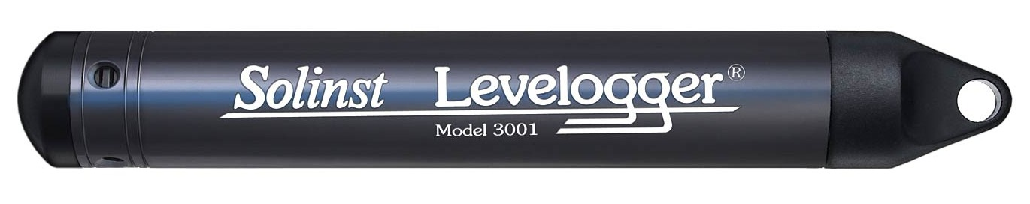
- Solinst Levelogger EdgeQR

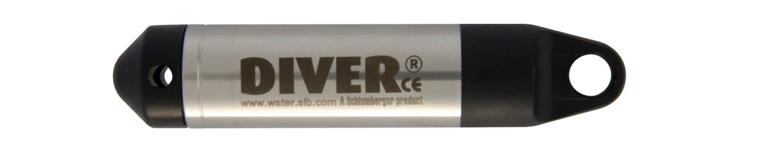
- Schlumberger Micro-DiverQR

Freeman et al. (2004) provides a guide to the proper selection, installation, and operation of submersible pressure transducers and data loggers for the collection of hydrologic data, primarily for the collection of water-level data from wells.
These instrument are generally suspended at a fixed depth in a well or the piezometer from a stable fixed point called the hanging point, often secured directly to the well casing itself.
These instruments record the absolute pressure (non-vented) and their output must be compen- sated for barometric pressure in order to obtain a measure of the water level elevation. This is done by subtracting the barometric record from the water-level record. This gives the height of the water column above the instrument.
Some instrument record the absolute gage pressure. Is measured in reference to atmospheric pressure at mean sea level. Pressures measured by a gage-pressure transducer are positive for pressures greater than sea-level pressure and negative for pressure less than sea-level pressure. Thus, atmospheric pressure measurements above sea-level datum are negative because atmospheric pressure decreases with altitude.
The new
Pressure changes occur in response to changes in the height, and thus in the weight of the water column in the well above the transducer.
DEPTH OF INSTALLATION
The principal objective of selecting a submergence depth at which to hang a transducer during installation is to ensure that water levels do not exceed the transducer’s operational range or fall below it during the monitoring period. Historical water-level measurements can be helpful when designing a long-term water-level monitoring program (Taylor and Alley, 2001). If enough measurements have been made, it is much easier to determine what daily or seasonal extremes can be expected for a given well. Thus, the appropriate range for a transducer can be selected, and its optimum position estimated. To minimize potential for errors and simplify subsequent data processing, reposition the transducer infrequently. Under ideal conditions, the transducer can be hung at a single depth for the entire monitoring period, although it may be necessary to re-position a transducer once
When data have been collected for a sufficient amount of time, WHAT can provides useful insight about past water level comportment and can also be used as a tool for predictive scenario. This can help to better design the optimal depth of installation of the instrument.
Even though there exists software that can correct data automatically for barometric pressure, it is still advise to have a basic understanding of the theory.
This is particularly usefull to correct situations when something goes wrong. For example, the barologger may had a deficiency and atmospheric pressure needed to be taken from the CDCD for example and data needed to be corrected manually. There arise often situation when correction needs to be done manually. This happens when there is a problem with the data. This is then good practice to understand the process in order to dodge mistake.
It is a good idea to monitor water level at a 15 min frequency for a period of a year, or more if it is possible. The data can be used subsequently to estimate the barometric response function of the well that can be quite useful to understand the hydrogeological context, and the level of confinement of the well. Having data with this frequency is also useful for running FFT and understand the cause of possible unatural fluctuation in the well.
Observations of land use, or changes in the general area of the site can be important for data analysis, record compu-tation, and data interpretation. These observations could be notes on land-use changes, construction of new wells nearby, notes of flowmeter readings from production wells, mention of known floods or earthquakes that occurred since the last visit, or any other item that might have a bearing on data collection.

Format des donn´ees brutes
Cela implique que pour pouvoir calculer la hauteur de la colonne d’eau, heau, situ´ee au-dessus des sondes (voir figure 1), la pression atmosph´erique doit ´egalement ˆetre connue `a chacun des
puits. A`
cet effet, des sondes barom´etriques ont ´egalement ´et´e install´ees dans la majorit´e des puits
d’observation du projet Mont´er´egie Est. Une attention particuli`ere a ´et´e port´ee afin d’assurer que les puits qui n’´etaient pas munis d’une sonde barom´etrique ´etaient situ´es `a proximit´e et `a une altitude raisonnablement similaire d’un puits ou` la pression atmosph´erique ´etait mesur´ee.
La profondeur de la nappe par rapport a` la surface, Znappe, est calcul´ee via l’´equation suivante
:
ou` Znappe (m) et Zsonde (m) correspondent respectivement `a la position de la nappe et la
profondeur d’installation de la sonde a` niveaux d’eau par rapport a` la surface du sol, htot (m) est
heau = htot - hair
Barometric
logger



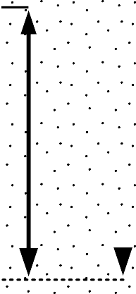
Figure 7.2: Typical instrument configuration for water level monitoring in an observation well
Water level
logger
Znappe
Zsonde

la charge totale mesur´ee par la sonde `a niveaux d’eau et hatm (m) est la charge mesur´ee par la sonde barom´etrique. L’axe des z est d´efini positif vers le haut avec, pour niveau de r´ef´erence, la surface du sol. Ainsi Zsonde et Znappe ont des valeurs qui sont g´en´eralement inf´erieures a` z´ero, a` moins que le niveau de l’eau dans le puits ne soit situ´e au-dessus de la surface.
Au cours du projet, trois mod`eles de sondes ont ´et´e utilis´es pour la mesure des niveaux d’eau:
(1) levelogger Gold de Solinst, (2) levelogger Edge de Solinst et (3) Micro-Diver de Schlumberger. Parall`element, deux mod`eles de sondes ont ´et´e utilis´es pour la mesure de la pression atmosph´erique:
(1) barologger Gold de Solinst et (2) barologger Edge de Solinst. Il est important de savoir que la m´ethode de stockage des donn´ees brutes varie d’un instrument `a l’autre. C’est-`a-dire que des transformations math´ematiques sont parfois appliqu´ees sur les mesures avant de les mettre en m´emoire. En g´en´eral, cela ne cause pas de probl`eme car les logiciels de traitement des donn´ees fournis par les fabricants g`erent le tout de fac¸on automatique et implicite. Par contre, lorsqu’une manipulation manuelle des donn´ees brutes est n´ecessaire ou lorsque des analyses plus complexes sont envisag´ees, une connaissance des diff´erentes strat´egies de stockage des instruments est essentielle. Pour les sondes levelogger et barologger Gold, les donn´ees brutes enregistr´ees par les instruments correspondent aux pressions mesur´ees, converties en hauteur d’eau ´equivalente, moins une constante dont la valeur est ´etablie en fonction de la pression atmosph´erique minimale anticip´ee au niveau
de la mer et de l’altitude fournie `a la sonde par l’utilisateur lors de sa programmation (9.5 m - 0.0012 m par m`etre d’altitude). Pour les sondes Micro-Diver et Levelogger Edge, les donn´ees brutes enregistr´ees par les instruments correspondent aux pressions mesur´ees converties en hauteur d’eau
´equivalente. Enfin, pour les sondes barologger Edge, la pression atmosph´erique est directement mise en m´emoire sans aucune transformation pr´ealable. Le Tableau 1 r´esume les diff´erentes op´erations math´ematiques qui sont appliqu´ees aux mesures avant de les mettre en m´emoire pour les diff´erents types de sondes qui furent utilis´ees au cours du projet Mont´er´egie.
ou` Ptot (kPa) est la pression absolue ressentie par la sonde a` niveaux d’eau, Patm (kPa) est la pression atmosph´erique, rho (kg/m3) est la masse volumique de l’eau, g (m/s2) est l’acc´el´eration gravitationnelle terrestre et Zalt (m) est l’altitude du puits fourni `a la sonde par l’utilisateur lors de sa programmation.

Estimation of missing daily weather data

Introduction
Climate data are useful in several fields of Earth sciences, including hydrology, hydrogeology and agronomy. However, climate datasets are, most of the time, incomplete. This can represent a major issue in various applications, such as for hydrological or hydrogeological model simulations that heavily depend on these data. For example, the method WHAT is using for the estimation of groundwater recharge requires serially complete (no missing data values) air temperature and precipitation daily datasets. The quality of the groundwater recharge assessment made with this technique is highly dependent upon the quality of the weather dataset used. Hence, the development of a reliable and accurate gap-filling procedure has been made an integral part of the groundwater recharge assessment in WHAT.
A guide for the preparation of gapless weather data series was presented in Section 3. This section presents a brief literature review on the subject, followed by a detailed description of the method implemented in WHAT for the estimation of missing daily weather data. Finally, an application is presented for the Montérégie Est region, located in southern Quebec, Canada.

Literature review
Filling the gaps in weather datasets can quickly become a tedious task, as a function of the dataset size and number of selected stations. Moreover, it can also become rather complex when constraints such as time-efficiency of the method, accuracy in the estimation of the missing values, and preservation of the statistical properties of the weather time series (probability distribution and normals) are taken into account. This is particularly true for the estimation of missing daily precipitation data because of their high spatial and temporal variability (Simolo et al., 2010).
The creation of a serially complete weather dataset generally consists in the replacement of missing daily data with estimated values calculated from simultaneous observations at nearby stations. Within-station method, i.e. methods that only use data from the series being filled, have been proven to perform poorly compared to methods based on the use of data from multiple neighboring stations. They are, moreover, ill-adapted for the reconstruction of daily precipitation time series (Eischeid et al., 1995; Kemp et al., 1983; Simolo et al., 2010).
Numerous spatial interpolation techniques exist for handling missing data in the weather time-series of a given station that are capable of? using data from irregularly spaced neighboring stations (e.g., simple arithmetic averaging, inverse distance method, single best estimator and multiple regression analysis). Eischeid et al. (2000) found that the multi-linear regression (MLR) method (DeGaetano et al., 1995) usually outperformed six commonly used techniques while testing the creation of serially complete daily temperature and precipitation datasets in the U.S.. Similarly, Xia et al. (1999) also found that the MLR method was consistently the most accurate out of the six classical methods tested to estimate missing daily weather data in Bavaria, Germany. One of the advantage that the MLR approach has over many classical methods is that it can account for local effects, such as topography, land cover, land use and surface water.
However, weighing and regression-based techniques, including the MLR method, all tend to slightly? overestimate the number of rainy days, while heavy precipitation events are systematically underestimated (i.e., the rainfall probability distribution is usually not preserved with these techniques). However, Simolo et al. (2010) have proposed a two-step procedure to modify the MLR method to address these issues.
In recent years, the estimation of missing daily weather data using artificial intelligence techniques have been the subject of many research studies (Abebe et al., 2000; Coulibaly and Evora, 2007; Kashani and Dinpashoh, 2011; Kim and Ahn, 2008; Srikanthan et al. 2005; Teegavarapu and Chandramouli, 2005). Kashani and Dinpashoh (2011) found that these new data-driven methods, more specifically the artificial neural network and the genetic programming techniques, outperformed the classical application of the MLR approach for three different climates in Iran. Artificial intelligence techniques are interesting because, unlike the classical weighing and regression-based methods, they are able to reflect the inherently stochastic nature of natural processes. Nevertheless, Kashani and Dinpashoh (2011) concluded that the MLR method was an appropriate technique as it performed best? among the eight traditional methods tested, for all the weather variables (air temperature, wind speed, relative humidity and precipitation) for different climate conditions (dry to extra humid conditions) (Kashani and Dinpashoh, 2011).

Description of the method
Although there exist various methods to estimate missing daily weather data that are well covered in textbooks and technical papers, very? few tools to perform this task efficiently and conveniently are available. The implementation of some of the more complex (and often most accurate) methods discussed in the above section can be a troublesome and even daunting task for a research study that is not directly related to the fields of meteorology or geostatistics. Because of time and resource constraints, it could be tempting to handle the problem of missing daily weather data with a simple method that will not provide accurate estimates for the given dataset. For instance, the use of a simple and straightforward? within-station linear approach between two dates to fill gaps in daily air temperature and precipitation is not appropriate for these weather data (Eischeid et al., 1995; Kemp et al., 1983; Simolo et al., 2010).
The method for filling the gaps in the weather time-series of air temperature and precipitation in WHAT is based on the implementation of the classical MLR method presented in Eischeid et al. (2000). The rationales behind this choice was to provide in WHAT a robust, efficient, accurate, and well known method that was well suited to most conditions (e.g. climate, land cover, topography). Based on the literature review presented in section 8.2, this choice appeared to be the best default option for the first version of the software. Since the programming? code for loading and manipulating the entire weather dataset of a given study area is object-oriented, it will be relatively easy to add modifications to the currently available approach, such as the two-step procedure for the MLR method proposed in Simolo et al. (2010) and/or one of the new artificial intelligence techniques that were developed in recent years (Kashani and Dinpashoh, 2011).
In addition to the handling of missing data, WHAT includes a jackknife resampling technique, to conveniently validate and assess the uncertainty of the estimated missing values. This feature will represent a valuable tool for quickly testing the performance of the different methods available to fill data gaps in a future version of the software. The entire gap-filling process used in WHAT is illustrated in the flowchart in Figure X.

Step 1: Pre-processing

Quality Control
Prior to the analysis of climatic time-series, it is important to apply quality control constraintsto ensure that the data do not violate obvious constraints associated with minimum, maximum, and average daily air temperature and daily cumulative precipitation. This step is not included in the gap filling routine per se. It is why it does not appear in the flowchart of Figure 8.1. It is done every time the software scans the ‘‘Input’’ binder for new weather data file and load them into memory (see Section X).
The program will identify irregularities or inconsistencies to insure that maximum, minimum and average daily temperatures are coherent for a given day and that all daily precipitation values are positive. When inconsistencies are detected, the program issues a warning and offers the choice to replace these erroneous values with ‘‘NaN’’, so that they can be estimated by the program from neighboring stations.

Station Correlation Assessment
The subsequent step consists in calculating the correlation coefficients between data of the target station and those of the neighboring stations for each of the four weather variables: minimum, maximum and average daily temperatures and daily cumulative precipitation. These coefficients are calculated for the entire time-series for each neighboring station individually. If there are less than 182 synchronous values between the data of the target station and those of a neighboring station for a given variable, the correlation is not computed and a ‘‘NaN’’ value is kept instead.
An alternative approach would have been to calculate the correlation coefficient with a subset of data from the target series centered around the missing value, as it was done in Simolo et al. (2010) for instance. This approach allows for a better representation of the seasonal variations in the relationships between the stations. The downsides include a more complex algorithm to implement and a reduction of the method robustness and efficiency. This alternative would provide, however, a good additional option in a future version of WHAT and its impact on the accuracy of the method should be assessed.
Based on our experience with daily weather data in Canada, the correlation coefficients between time-series of air temperature measurements is generally higher than 0.98 for stations located at a distance of 100 km or less. The relationships for precipitation are much more sensitive to variations in the landscape (land cover, topography, surface water). As a result, correlation coefficients are generally less than for air temperature and decrease more rapidly with the distance from the target station. A value higher than 0.8 is generally deemed acceptable. This threshold is usually reached for stations within 100 km and with an elevation difference of less than 350 m, the default values in WHAT. Data correlation between two stations will generally decreases as the horizontal and vertical distances increase. It is possible to specify a cutoff distance and a cutoff altitude difference for which neighboring stations that fall above these cutoff values are ignored by the program. The default values are set to 100 km and 350 m for the horizontal and vertical distance respectively based on the literature (Simolo et al., 2010; Tronci et al., 1986; Xia et al., 1999).

39

Correlation coeﬃcients are calculated between stations for all the climatological variables.
Calculate Correlation Coeﬃcients
j = 1
Load MLR Model Coeﬃcients from Memory
j = j + 1
i = 1
i = i + 1
Select Neighboring Stations
Calculate MLR Model Coeﬃcients
Do Nothing.
(a "NaN" value is kept)
Estimate Missing Value for that day
Select a Target Station

Loop A

Loop B

Loop over all climatological variables (Nvar). Variables for which there is too few data are ignored.

Loop over all missing value for the jth climatological variable.

Stations are selected in descending order of their correlation coeﬃcient, up to the

parameters. Stations not respecting the distance and cutoﬀ criteria are ignored.

Checks if there are neighboring stations
with data for the day corresponding to the ith missing value in the time series
of the jth climatological variable

Stations with data > 0 ?

YES

NO First time
this station sequence is
encountered?
YES

NO i = Nmissing*

YES

NO
j = Nvar**

YES

Save the Gapless Dataset

Figure 8.1: WHAT workflow for the gap-filling procedure for weather time-series.???

40

Step 2: Filling the Gaps
The procedure for filling the gaps in the weather data includes two nested loops. The external loop, labeled ‘‘Loop A’’ in Figure 8.1, iterates over the time series of four weather variables for the target station. The inner loop, labeled ‘‘Loop B’’, iterates over every missing value in the data series. The process for the estimation of a single missing value is basically a two-step procedure. The first step consists in selecting the data series with the best correlation coefficient. The second step consists in building a MLR model and estimating the missing values. This is described in more details below.

Selection of the neighboring stations
The selection of surrounding stations is critically important for the accurate estimation of missing weather data (Eischeid et al., 1995). However, even if stations are well correlated, problems may arise because of synchronized missing values in the target and neighboring weather station datasets. This is illustrated in Table 8.1, where theoretical time-series of air temperature data with a realistic distribution of missing values are presented.
Table 8.1: Example of well-correlated stations with multiple missing data

Target Neighbors

Day | X | Y1 | Y2 | Y3 | Y4
1 | 11.0 | 12.0 | 12.0 | 12.5 | 10.0
2 | nan | 12.0 | nan | 13.0 | 12.2
3 | 7.5 | 8.5 | 8.5 | 8.0 | 8.9
4 | nan | 6.0 | 4.5 | 5.0 | 4.4
5 | nan | 8.0 | 8.5 | nan | nan

In Table 8.1, there are missing values in the target station dataset for days 2, 3, and 5. The missing value on day 2 will then be estimated with the data of the neighboring stations Y1, Y3, and Y4 since station Y2 is also missing a value on this day. All neighboring stations will be used for the estimation of the missing value on day 4, while only stations Y1 and Y2 have data available for the estimation of the missing value on day 5.
Since the number of neighboring stations with available data is not fixed in time, it is not possible to use a single MLR model to fill all the missing values for the target station all at once. For each missing value in the target station dataset, the program keeps only the datasets of the neighboring stations that also have data at this particular time. Data series of stations that do not respect the cutoff criteria for distance and elevation differences are also ignored. Data from neighboring stations are selected in descending order of their correlation coefficient with the target station, up to a maximal number of stations defined in the method parameters. The default value for the maximal number of neighboring station was set to four, based on the literature (Eischeid et al., 1995; Xia
et al., 1999).

41
If for a given day, no neighboring stations have a measured value to fill a gap in the target station dataset, no calculation is done and a ‘‘NaN’’ value is kept in the series instead and the program pass to the next missing value in the target series. An estimated (filled) value cannot be used to fill gaps of other station datasets.???

Multiple Linear Regression Model
First, the program will be checking if the sequence of neighboring stations has already been encountered for the current weather variable and, if so, will load the MLR parameters from memory and will directly estimate the missing value. Otherwise, the model will generate a new MLR model using either an Ordinary Least Square (OLS) or a Least Absolute Deviations (LAD) criteria (both options are available in the module?).
Since daily precipitation series generally have a positively-skewed distribution, the LAD criterion is typically a better option than the OLS criteria for handling this kind of distribution because it is more robust to outliers (Eischeid et al., 2000, 1995). The downside is an increase in computation time. The MLR using a LAD criterion is computed in WHAT with an iterative reweighted least-squares method (Schlossmacher, 1973; (Eischeid et al., 1995).

Estimating Missing Daily Values
When the parameters of the MLR model for a given day with a missing value are known, the missing value in the target time series is estimated as:

N
X(t) = a0 + )"' ai · Yi(t) (8.1)
i=1

where X(t) is the missing value of the target station estimated at time t, Yi are the synchronous values of the neighboring stations, ai are the regression coefficients and N is the total number of neighboring stations used for the regression, up to the maximal value defined in the method (default is four).
When all missing values in the target station dataset have been estimated, the resulting gap free time series is saved in a ‘‘.out’’ file. Detailed information about the estimated values are saved in an accompanying ‘‘.log’’ file (see Section 8.3.1).

Step 3: Validation
WHAT also includes an option to perform a validation of the method used for a particular weather dataset with a jackknife procedure. This option is an advanced feature that can be activated by changing the value of the field ‘‘Full Error Analysis’’ from 0 to 1 in the file named ‘‘WHAT.pref’’ (see Section 8.3.1).
More specifically, when this option is activated, WHAT will estimate a value for the target station for every day of the time series. In other words, loop B in the flowchart of Figure 8.1 will run over all the days of the dataset and not only over days for which there is a missing data. In addition, the memory feature will be deactivated and a MLR model will be estimated for each day independently. If a measured value is present for the current day being estimated, this value will be temporarily discarded from the data series to avoid self-influence of the observation on the estimation procedure. Je ne comprends pas bien comment tu fais ton jacknife. Est-ce que tu le fais en utilisant 1 à 4 valeurs des stations avoisinantes pour les jours où il y a des données observées à la station sélectionnée, et tu compares la « vraie » observation à l’estimation? Ce n’est pas clair.
Consequently, the activation of this feature will significantly raise the computation time for filling the gaps in weather time series and should be used only when a detailed analysis of the estimation errors is required. The default information provided in the ‘‘.log’’ should contain sufficient material to fill the needs of a large number of projects. Thus, this process leads to the production of a weather time-series for which every value has been estimated in WHAT. The results are saved in a TSV (tab-separated values) text file with the extension ‘‘.err’’ that is named after the station name and ID similarly to the ‘‘.log’’ and ‘‘.out’’ files.
The accuracy of the estimation technique can then be assessed by comparing the estimated weather data with the respective non-missing observations in the original weather data file. There is currently no tool provided in WHAT to directly analyze the results from the Jackknife procedure. However, all the source code that has been written? for the production of the figures of Section 8.4 can be downloaded freely on GitHub at (https://github.com/jnsebgosselin/WHAT).

Monteregie Est Case Study
The Monteregie Est region is located in southern Quebec, Canada, on the south shore of the St. Lawrence River. It covers a total area of 9032 km2, from the St. Lawrence River at its northern limit to the border of the United States (states of New York and Vermont) at its southern limit (see Figure X).
This region has been the subject of an extensive characterization project within the ‘‘Programme d’acquisition de connaissances sur les eaux souterraines du Qu´ebec’’ (PACES) whose main objective was to prepare a realistic and concrete picture of the groundwater resources for the region (Carrier et al., 2013).

Materials and Method
The climate is characterized by significant seasonal differences in temperature, resulting in warm summers and cold winters. Precipitation, as rain or snow, are distributed rather evenly throughout the year.
Among all the weather stations for which data were available in and around the study area, a total of 32 was selected based on the availability and continuity of the weather data between 1980 and 2014. A list of these selected stations is presented in Table X with their coordinates, altitude, total time periods for which data were available, mean annual cumulative precipitation, and mean annual air temperature. Most of these information are generated automatically by WHAT in the file ‘‘weather datasets summary.log’’ (see Section 2.4).
Pour l’ensemble de ces stations, les pr´ecipitations totales annuelles sont d’environ 1100 mm/y
en moyenne. Les pr´ecipitations totales les plus ´elev´ees sont observ´ees `a la station de Brome (∼1280 mm/y et les plus faibles `a la station de Sorel (∼960 mm/year). La temp´erature annuelle
moyenne dans la r´egion d’´etude est de 5.9 ◦C, variant de 4.3 to 6.7 ◦C tandis que les temp´eratures mensuelles moyennes fluctuent entre −12 to 21 ◦C. Les temp´eratures mensuelles minimales sont observ´ees en janvier (−17.1 to −13.6 ◦C) tandis que les temp´eratures mensuelles maximales sont
observ´ees en juillet (24 to 26.7 ◦C). Les temp´eratures les plus ´elev´ees sont g´en´eralement observ´ees aux stations de Philipsburg et Saint-Bernard-de-Lacolle (temp´erature annuelle moyenne de 6.7 ◦C) et les plus faibles `a la station de Bonsecours (temp´erature annuelle moyenne de 4.3 ◦C)
Les figures 1.3 et 1.4 illustrent respectivement les variations spatiales des pr´ecipitations totales annuelles et de la temp´erature moyenne annuelle pour la p´eriode de 1970-2000. Les valeurs pr´esent´ees sur ces figures ont ´et´e interpol´ees par krigeage ordinaire sur une grille de 250 x 250 m, a` partir des valeurs rapport´ees pour les 16 stations actives mentionn´ees ci-haut.Dans la r´egion d‘´etude,
Table 8.2: List of selected weather stations in the study area and related information about missing data for the 1980-2014 period

Percentage of missing data (%) Stations ID Lat. Lon. Alt. Tmax Tmin Tavg Ptot TOTAL

la tendance g´en´erale indique que les pr´ecipitations annuelles totales diminuent du sud-sud-est vers le nord-nord-ouest et que les temp´eratures annuelles moyennes diminuent du sud-ouest vers le nord-est. Outre l‘influence de la latitude, la temp´erature de la r´egion est ´egalement influenc´ee par la pr´esence des Appalaches au sud-est et du fleuve Saint-Laurent au nord-ouest.

STE BEATRIX

ST JACQUES

!(
SOREL

PIERREVILLE
!(

Legend Weather Stations Limit of the study area
Thiessen Polygons

DRUMMONDVILLE

DANVILLE

ST GUILLAUME

RIVIERE DES
PRAIRIES

VERCHERES

STAMABLE

!(
FLEURY

ST NAZAIRE

RICHMOND

AUTEUIL

STE MADELEINE

ST HYACINTHE 2

MARIEVILLE

GRANBY
BONSECOURS

IBERVILLE FARNHAM M

STE MARTINE

BROME

SABREVOIS

HEMMINGFORD FOUR WINDS

ST BERNARD DE LACOLLE

PHILIPSBURG

SUTTON
GEORGEVILLE
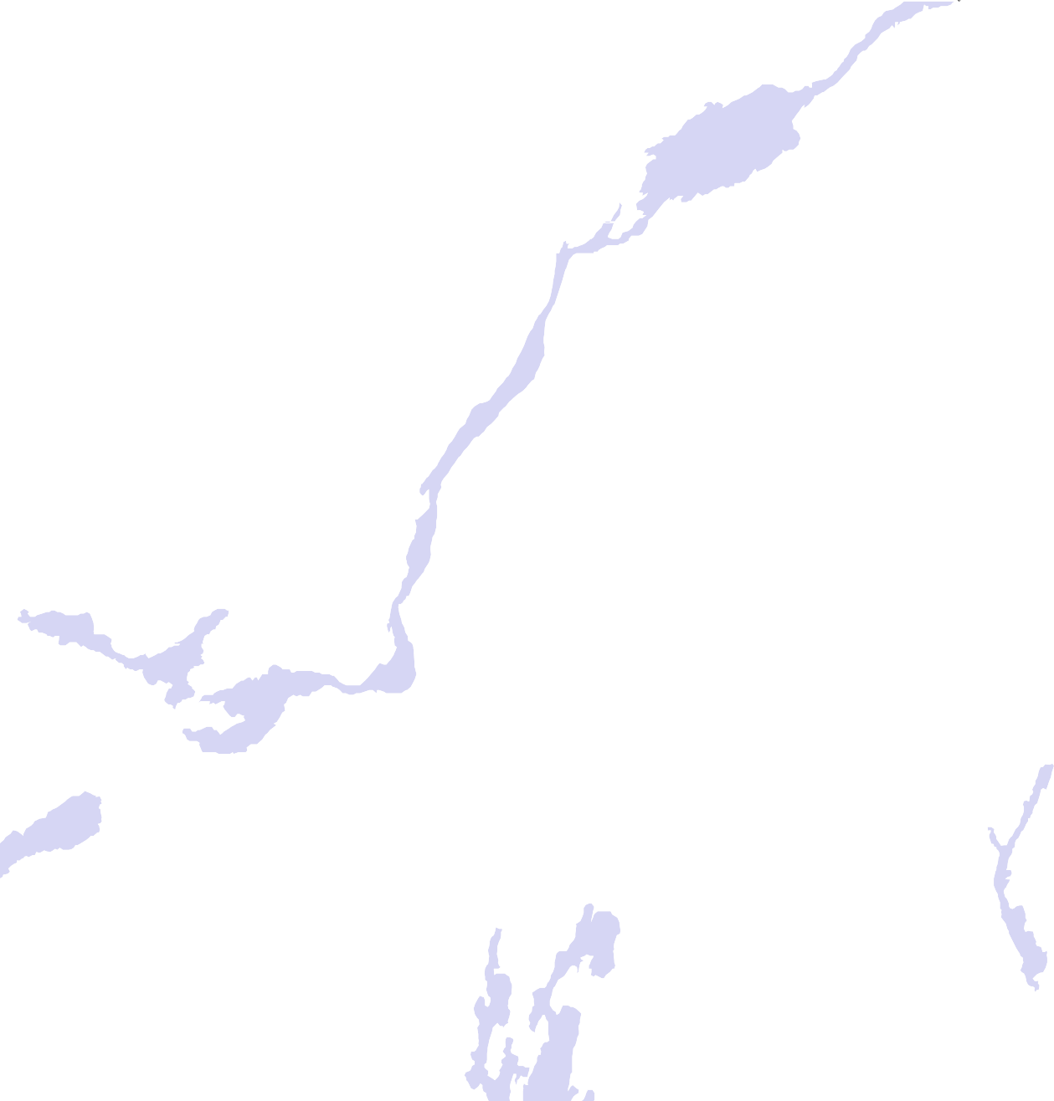

Figure 8.2: Locations of the weather stations in the Monteregie Est area.

The weather network of the Monteregie Est region, located in the province of Quebec, Canada, has been used to test the method. This region feature strongly variable topography and land cover conditions. The network is presented in figure X. Also, stations from bordering states were extracted to improve the spatial distribution of sites surrounding target stations located near state borders.
Daily weather data for 32 weather stations in and around the Monteregie Est area were also retrieved from the Canadian Daily Climate Database (CDCD) with the software WHAT for the years 2000 to 2012. Missing values in the weather time series were also estimated with WHAT to produce gapless meteorological records of daily air temperature and precipitation.
Tests have shown that inclusion of more than four stations does not significantly improve the interpolation and may in fact degrade the estimate.

Results and Discussion
The quality of the estimates is strongly affected by seasonality. Stations at higher elevations are difficult to estimate accurately, in large part because of the topographical diversity of the surrounding stations leading to degradation of spatial coherence among stations.
The tendency for all of the methods to have a negative bias is indicative of the nature of precipitation distributions to be positively skewed (interpolated values will tend to cluster about the median error rather than the mean).
According to Xia et al. (1999), the two most important factors in climatology are the inter- correlations in the station network, and the seasonal variations in the relations between the stations.

Future Work

MRC Estimation

The mathematical expression describing the average behavior of the declining water-table at a particular site during period when groundwater recharge is negligible is called the Master Recession Curve (MRC). The strength of this correlation and thus the validity of the MRC depends on many factors including the local relief and topography, seasonality of the climate, hydraulic properties of the subsurface porous medium, and depth to the water-table (Heppner and Nimmo, 2005).
Estimation of the MRC from a well hydrograph is done in WHAT in two step. The first step consists in the determination of the local extremum in the hydrograph in order to identify the period of time when the water-table recedes and the groundwater recharge is supposed negligible.
La seconde ´etape consiste a` l’optimization des param`etres de l’´equation math´ematique d´ecrivant la MRC. The MRC takes the form of a linear relation between water-table elevation and water-table declining rate. The resulting water-table recession hydrograph has the familiar exponential decline shape (MONTRER UN EXEMPLE). :
Since the MRC can varie with seasonality of the climate, a different MRC can be estimated for the winter and summer. This option is not yet implemented in the code but will be shortly.
Water-table fluctuation principle states that recharge is the product of water-table rise and the specific yield. variation of water-table due to recharge can be difficult to estimate because water-tables typically are in transient state of decline between storm or recharge events. predict what the water-table elevation would be at the succeeding time step in the absence of recharge. The predicted water-table elevation is compared to the measured water-table elevation and the difference between these 2 values is multiplied by the specific yield to get recharge for that time step. The user is responsible for providing the best coefficient for the MRC function.

Local Extremum Search
The position of the local extremum in the water level time series can be estimated with the use of an automated algorithm that is based on a method presented in Chapter 6 of Vamo¸s and Cr˘aciun (2012).
Among the resulting receding segments, only the segments with a time span of more than a week are kept, and the shorter segment are disregarded. This is to remove receding segment that are due to noise. In any case, it is best to inspect Dans un premier temps, l’hydrogramme de puits est filtr´e par une moyenne mobile centr´ee avec une p´eriode d’une journ´ee afin de r´eduire le bruit haute-fr´equence. En second lieu, tous les maximums et minimums locaux sont localis´es par une approche automatis´ee dans Matlab. Une inspection visuelle est ensuite r´ealis´ee dans le but d’´eliminer les faux extr´emums ou encore pour identifier des extr´emums qui auraient ´et´e omis par l’algorithme.

Parameter Optimization
Cette approche a ´et´e utilis´ee pour l’estimation de la recharge notamment par Delin et al. (2007), Heppner et Nimmo ainsi que Crosbie et al. (2005). Plusieurs programmes sont disponibles pour la d´etermination automatique d’une CMR a` partir d’un hydrogramme de puits, dont les algorithmes d´evelopp´ees par Crosbie et al. (2005), Posavec (2006) et Heppner et Nimmo (2005). La Error: Reference source not found montre un exemple d’une courbe maˆıtresse de r´ecession obtenue pour le puits P0-19 (Mont Rougemont) avec le programme Visual Basic de Posavec (2006) utilisant une m´ethode automatis´ee d’appariement par bande.
La CMR ainsi d´efinie est par la suite utilis´ee pour tracer la projection de la courbe de r´ecession ant´ec´edente au lieu de proc´eder manuellement. Une estimation de la recharge peut ensuite ˆetre calcul´ee directement par l’application de l’´equation [1.
Cette technique a` l’avantage d’´eliminer une bonne partie de la subjectivit´e de l’utilisateur. De plus, contrairement a` l’approche graphique, elle permet facilement d’estimer la recharge en p´eriode de r´ecession de la nappe. Dans la litt´erature, l’approche CMR est g´en´eralement utilis´ee pour calculer la recharge pour tous les points de mesure constituant l’hydrogramme de puits. Cela rend cette approche tr`es sensible au bruit qui est souvent observable dans les mesures de niveaux d’eau.
(EXEMPLE– A`
VENIR) Ce bruit peut ˆetre attribuable par exemple aux variations de la pression
atmosph´eriques et aux mar´ees terrestres (Rasmussen et Crawford, 1997; Butler et al., 2011), a` du pompage, `a l’effet Lisse (Weeks, 2002; Crosbie et al., 2005), aux variations de temp´eratures ou encore par l’appareil de mesure mˆeme.
La r´eorganisation des termes et l’int´egration de l’´equation par rapport au temps entre deux points (tA,hA) et (tB,hB) d’un hydrogramme de puits, tel que d´efini a` la Error: Reference source not found, r´esulte en l’´equation suivante:

Well Barometric Response Function

Part III Appendices

Creating a Custom CDCD Weather Station List

WARNING: this section needs to be updated and revised.
The stations information need to be saved in a tabular-separated values text file with an “lst” extension. A template of a station list (station list template.lst) is provided with the program in the Zip archive and an example is presented in Error: Reference source not found. The fields Station Name, Year, Start, Year End and Province do not need to match strictly with the station’s URL. These fields can be assigned any name/value by the user and are not directly used in the downloading process of weather data. The only field that is directly used in the download process is Station ID that is a unique number attributed to each weather station.
Once a file containing a list of weather stations’ information has been created, it is possible to load it in Rainbird by clicking on the Load button located in the Fetch and Merge tab (Error: Reference source not found). The station list can be refreshed at any time by clicking on the Refresh button.

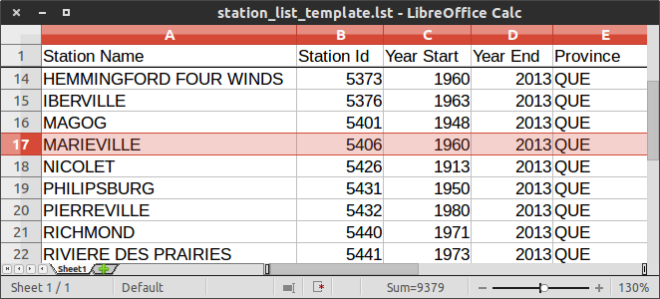
Figure A.1: Weather Station List (*.lst) Sample

Step 1 First go to www.climate.weather.gc.ca.

Step 2 At the bottom of the page, click on Advanced Search (see the red arrow in Figure A.2a).

Step 3 Search for a station either by Province, Name or Proximity. For this example, the search was made using the Name of the station (see Figure A2).

Step 4 The research yielded one result (Figure A3). For Data Interval, select Daily and click Go. WARNING: The downloading and formatting of Hourly data is not currently supported in WHAT (but could be in a future version of the software).
Step 5 The URL associated with Marieville weather station is:

http://climate.weather.gc.ca/climateData/dailydata_e.html?timeframe=2&Prov=QUE& StationID=5406&dlyRange=1960-06-01|2013-12-31&Year=2013&Month=12&Day=01.

From this URL, we find that its Station ID is 5406 (see red circle in Figure A4), that is located in the province of Quebec (QUE) and that data are available from 1960 to 2013.

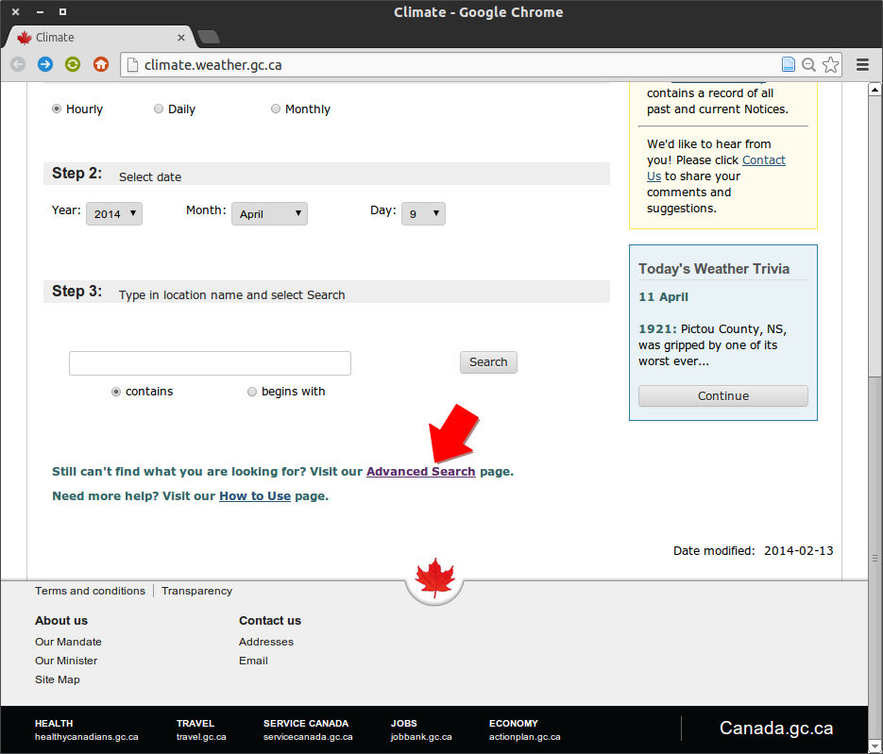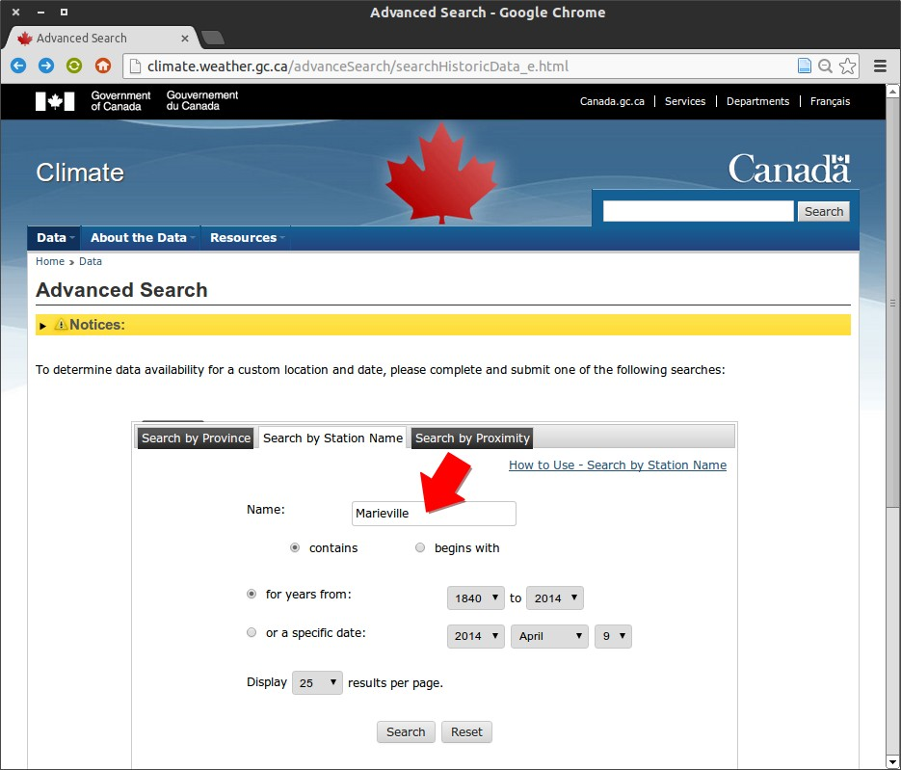
  - Step 1 (b) Step 2

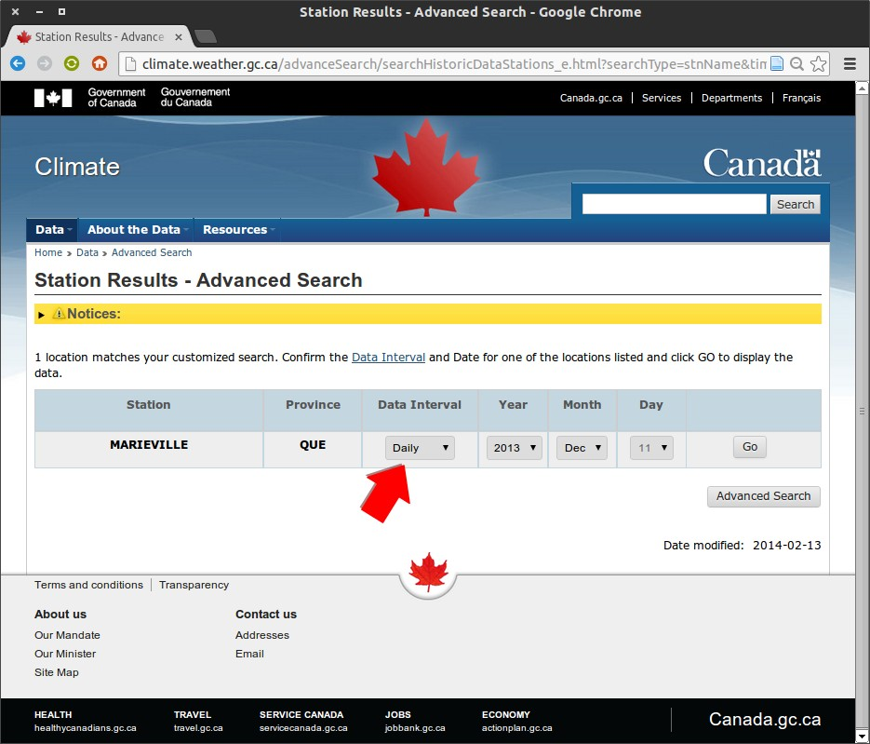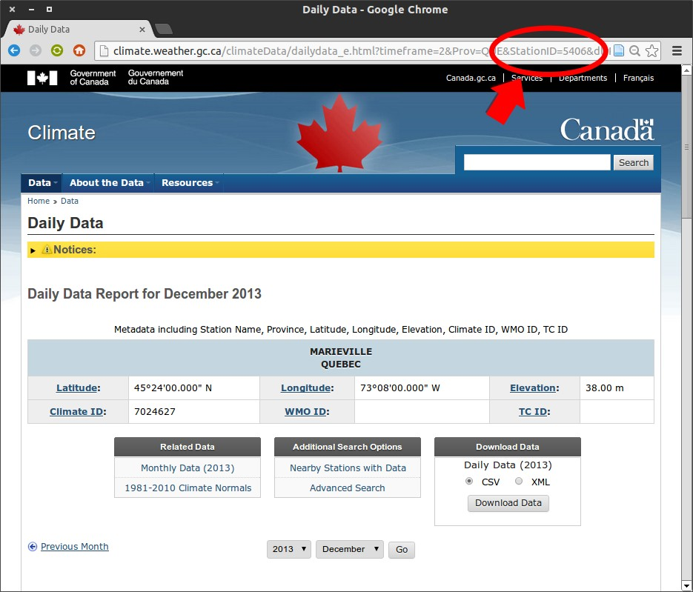
(c) Step 3 (d) Step 4

Figure A.2: Creation of a custom weather station list how-to

- Hydrogeological characterization of the regional bedrock aquifer confinement
conditions in Monteregie Est1

Methodology
Water levels were monitored in 44 observation wells during the PACES project in Monteregie Est for a period of approximately two years. The vast majority of the wells were installed in the regional fractured bedrock aquifer. Daily weather data for 32 weather stations in and around the Montérégie Est area were also retrieved from the Canadian Daily Climate Database (CDCD) with the software WHAT for the 2000 to 2012 period. Missing values in the weather time series were also estimated with WHAT to produce gapless meteorological records of daily air temperature and precipitation.
Thiessen polygons were generated using these 32 weather stations (see Figure B.1) and weather stations associated to each observation well were selected based on them. Then, automatic graphs were produced (generated) with WHAT, each presenting a hydrograph along with weather data from the nearest weather station.??? Hydrographs were inspected visually and grouped into three different classes according to the relative response of the groundwater levels to rainfall and snow melt events. These classes were considered representative of different confinement conditions of the regional bedrock aquifer:
(1) unconfined, (2) confined, and (3) semi-confined (or confined with regional influences from a nearby recharge area). The confinement condition of the regional bedrock aquifer has thus been defined at 35 sites, as a fraction of the 44 monitoring wells are multi-level wells that are located side by side. Figure B.2 shows three typical hydrographs associated to each confinement condition.

Results
The confinement conditions inferred from the well hydrographs were superimposed on the map showing confinement conditions that was produced for the regional bedrock aquifer based on the sequence and thickness of the surficial deposits (Carrier et al., 2013). Figure B.3 shows that the confinement conditions of the regional bedrock aquifer defined on the basis of the well hydrographs are generally consistent with those of the confinement condition map based on criteria related to geology. This is an interesting result considering that the two approaches are completely independent. That is, the definition of the confinement conditions of the bedrock aquifer for both approaches stems from criteria based on physical quantities that are very different in nature: time series of groundwater levels in one case and
1This work has been produced with the participation of Dr. Ren´e Lefebvre at INRS-ETE, 490 rue de la Couronne, Quebec City, Quebec, Canada.

STE BEATRIX

NICOLET

Legend

ST JACQUES

!(
SOREL

RS 01
!
Weather Stations
Observation Wells
PIERREVILLE Limit of the study area Thiessen Polygons
!(

P14B

RIVIERE DES

VERCHERES

P01

P08

!
P03

!(
FLEURY
P14A

ST GUILLAUME
!
RS 04
DRUMMONDVILLE

DANVILLE

AUTEUIL
PRAIRIES

STAMABLE

P13
RS 02B RS 02A

STE MADELEINE

P25

P15
ST NAZAIRE

!
P06

RICHMOND

P07 RS 05B
RS 05A

ST HYACINTHE 2
P12

P19

P04

P11

P09

BONSECOURS

P23
!
MARIEVILLE
GRANBY !

P02A P02B

P24

STE MARTINE
IBERVILLE FARNHAM !! M

P17

HEMMINGFORD FOUR WINDS

SABREVOIS
P05

ST BERNARD DE LACOLLE

PHILIPSBURG
P16A P16B

P10
P18B
P18A

P22A P22B

SUTTON
BROME

P20

P21

GEORGEVILLE

Figure B.1: Locations of the observation wells (blue dots) and the weather stations (yellow dots) in the Monteregie Est area.

spatial distribution of surficial deposits in the other. The confinement conditions inferred from the hydrographs further validate the criteria used to produce the regional confinement condition map which were based both on knowledge of the regional geological contexts and professional judgment and were, therefore, partly arbitrary.
Morover, the confinement conditions inferred from the well hydrographs are consistent with the four hydrogeological contexts that were defined for this study area (Carrier et al., 2013). These contexts are represented by thick dashed lines in Figure B.3 and were defined based on physiography, surficial geology spatial coverage, and characteristics of the bedrock formations. A discussion relative to each context is presented in some details in the following paragraphs.

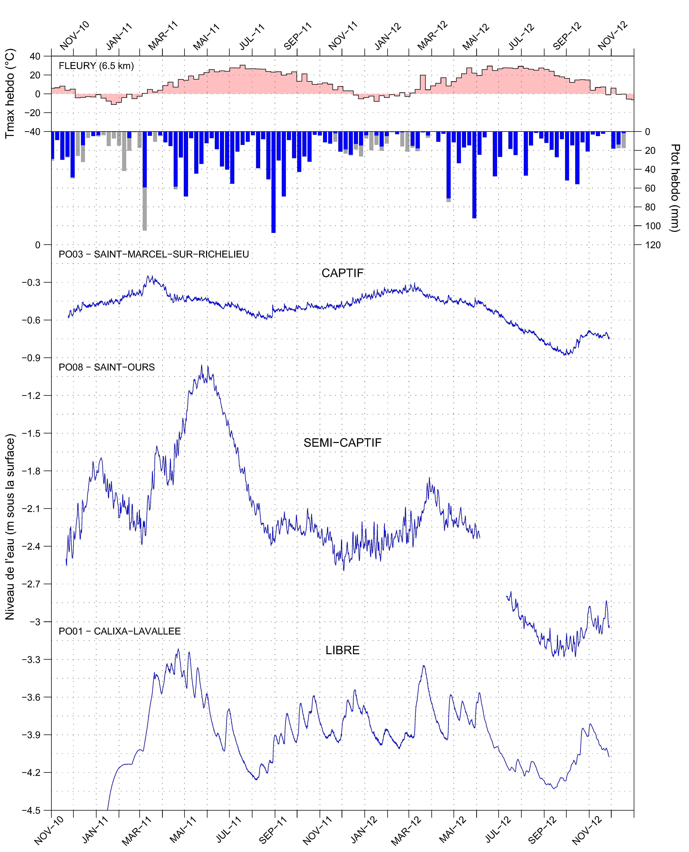
Figure B.2: Typical hydrographs representative of the three classes considered in the analysis of the confinement conditions of the regional bedrock aquifer in the Monteregie Est area, Quebec, Canada: (top) confined, (middle) semi-confined (or confined with regional influences), and (bottom) unconfined.
Traduire la figure. Au fait, est-ce que ton logiciel est en françait? Comme l’OF sera en anglais, ce serait bizarre que le logiciel soit juste en français Vas-tu discuter et indiquer les différentes caractéristiques des 3 courbes présentées? Ce serait important de résumer les éléments importants dans des boîtes qu’on pourrait mettre sur les graphiques eux-mêmes et peut-être même mettre des flèches pour identifier des choses importantes. Les critères, mêmes qualitatifs, qui te permettent de les catégoriser. Il faudrait aussi parler (reparler) de l’échelle, puisque l’analyse d’hydrogramme est relativement locale.

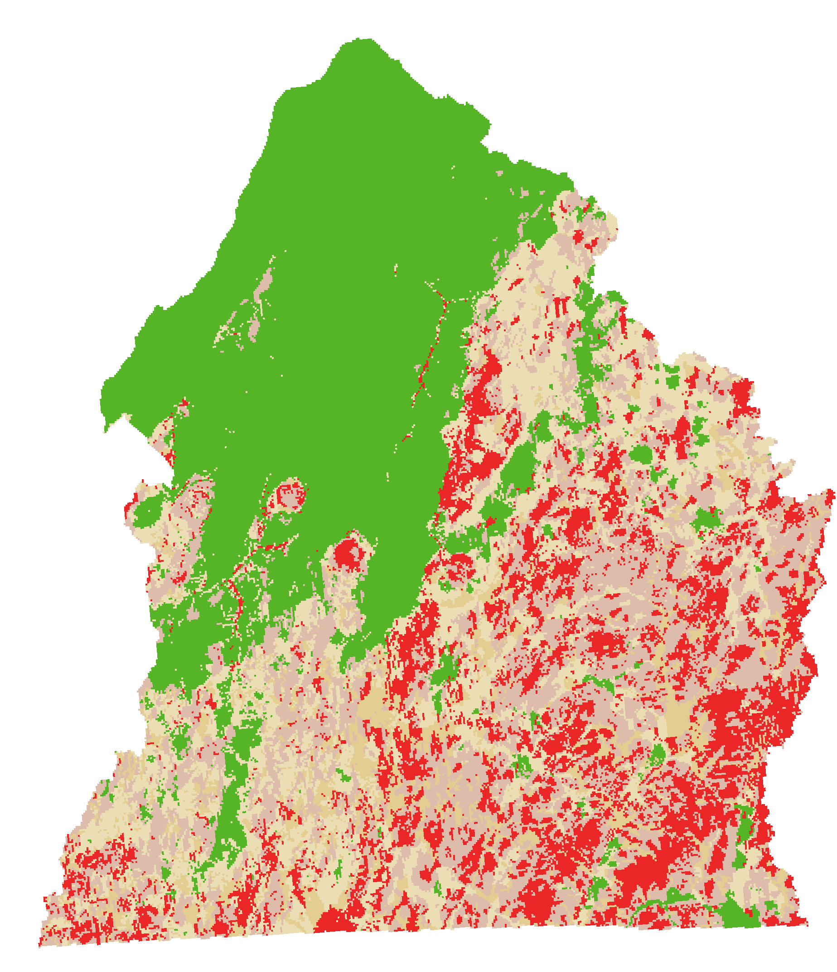
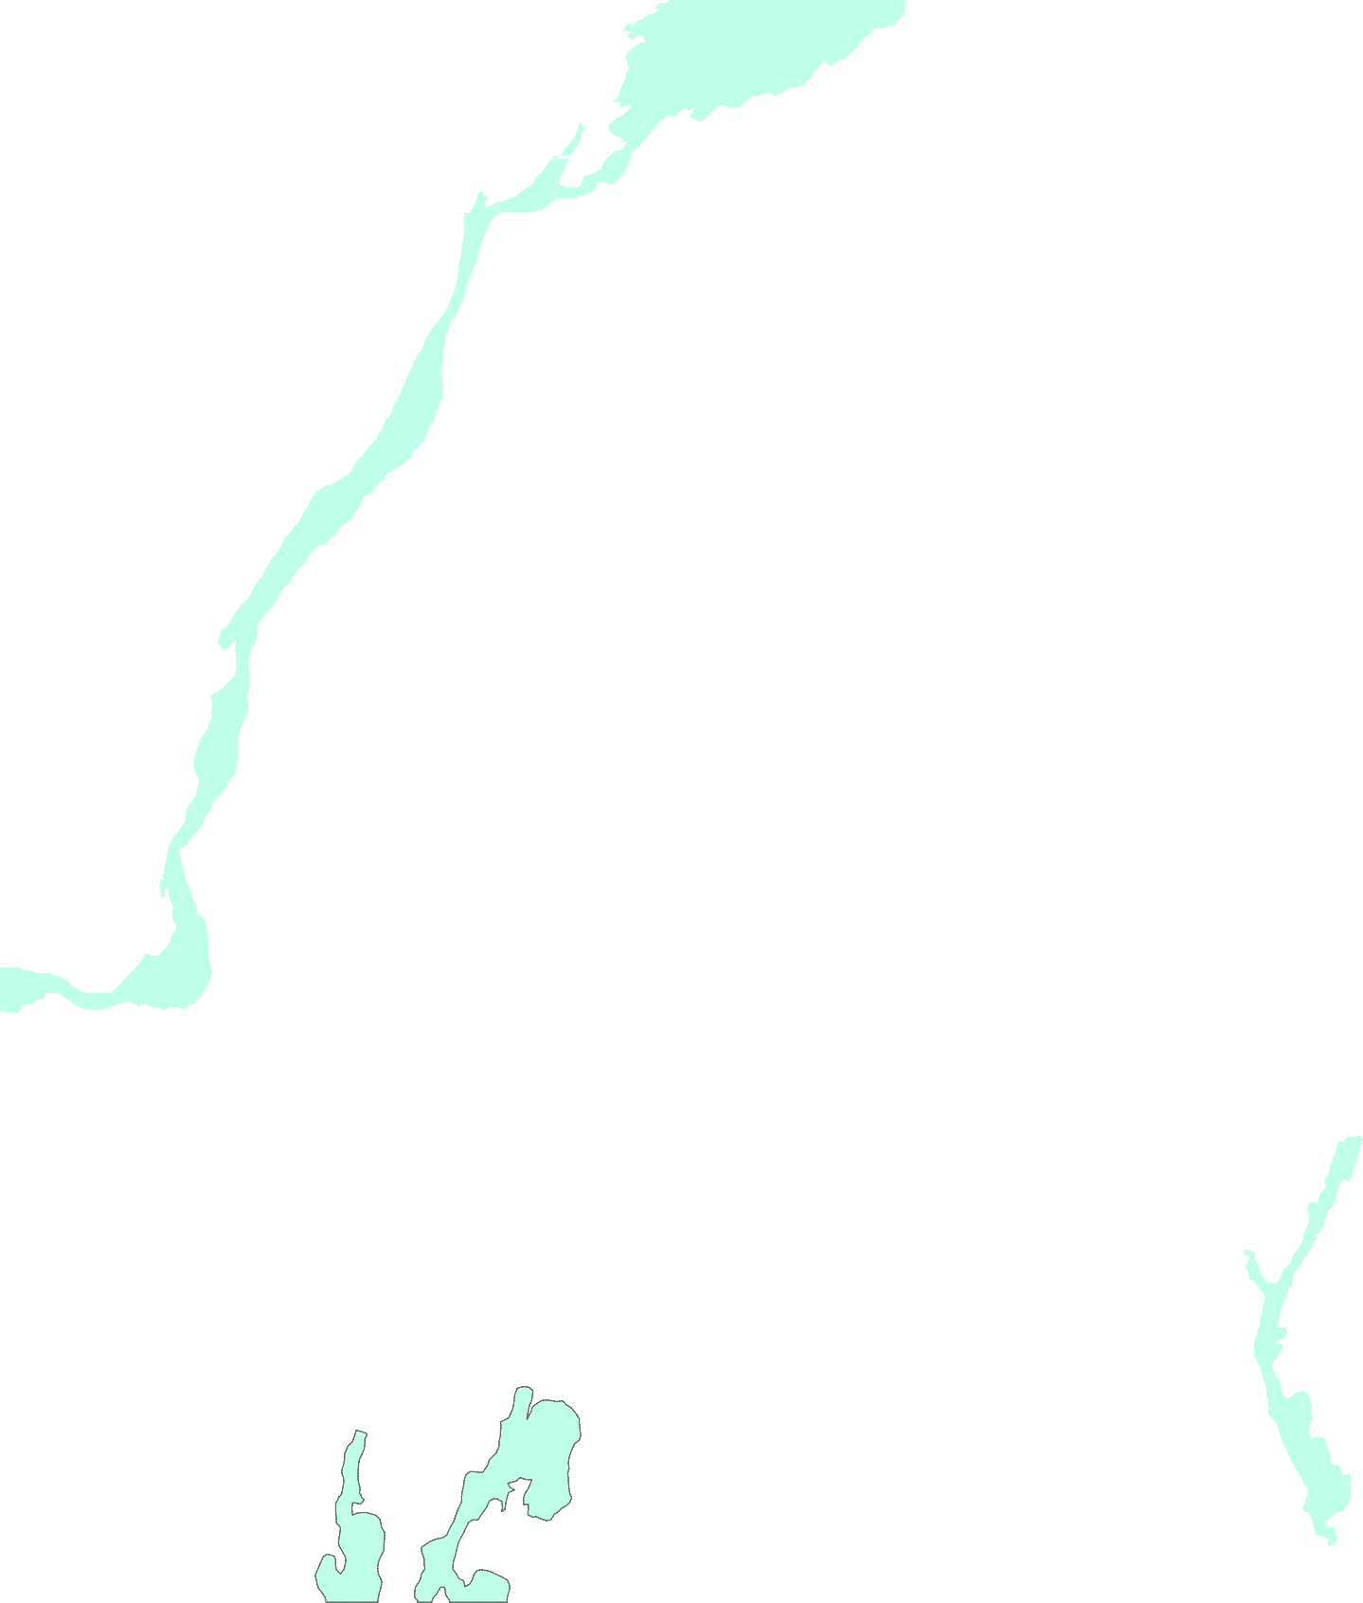

RS01

PO08
PO03 PO14B RS04

PO01

PO13

RS02B
Beige pâle?
PO15 PO06

PMSH

PO12
PO25

PO04
PO07

PO19 RS05B

PO11
PO09

PO23
PO24

PO02B
Beige foncé?
PO17

PO05

PO16B

PO18B

PO20

PO10

PO21

Figure B.3: Confinement conditions inferred from the well hydrographs (dots) superimposed on the confinement condition map of the regional bedrock aquifer. The colors indicate the confinement conditions of the aquifer, both for the map and the well symbols: green for confined, red for unconfined and two beige tones for semi-confined. 2 tons de beoge pour la carte et les puits? Les 2 tons de beige viennent d’où pour les puits?Il faudrait un titre pour cette section mais je ne sais pas trop quoi mettre. C’est une section bizarre, qui ne décrit ni vraiment le comportement des puits, ni les contextes. Description of the different hydrogeological contexts and associated hydrograph behavior??
St-Laurence Lowlands Observation wells that are representative of confined conditions are found exclusively in the St-Laurence Lowlands, particularly in the northern part where a thick layer of marine clay and silt is present. The interpretation of hydrographs is also consistent with the confinement conditions of the aquifer of this area at a more local scale. For example, observation well PO01 represents adequately the small recharge area that is located in the north-western part of the St-Laurent Lowlands, where the sediments close to the surface are coarser and the clay and silt cover thickness less important???. Also,
well PO08, located at a distance of ∼20 km from the well PO01 and at less than 7 km from the
limit of the recharge zone, is characterized by water levels that vary significantly on a seasonal
basis, in spite of the thick clay and silt layer (> 25 m) covering the bedrock at this location. These water-level fluctuations are most likely due to the influence of the nearby recharge area. The southern part of the St-Laurence Lowlands is characterized by wells representative of confined, semi-confined, and unconfined conditions that are distributed consistently with the nature and thickness of the surficial deposits. Combien y a-t-il de puits? Tu n’avais pas separer nord et sud comme dans le rapport? Car la couche d’argile et silt est nettement superieure au nord des Monteregiennes.

Appalachian Piedmont This context is characterized by wells that are exclusively representative of unconfined conditions. This is even the case for observation well PO18 where the rock is covered by more than 40 m of surficial sediments, mainly gravel, sand and silt. It is not clear if the strong correlation observed between the water-level fluctuations and the rainfall and snow melt events is due to direct recharge at the PO18 location specifically, or to an hydraulic influence of recharge in a nearby bedrock depression that is covered by a much thinner layer of surficial sediments. The calculation of the barometric response function for this well would be of a great help to answer this particular question.

Appalachian Highlands This context is characterized by wells indicating conditions ranging from unconfined to semi-confined. These results represent adequately the discontinuous cover of surficial deposits in this area. The fact that there is no well showing confined conditions, despite the important thickness of the surficial sediments in some valleys, suggests a significant hydraulic influence of recharge areas of the bedrock aquifer located in topographic highs on each side of the valleys. Well PO20 that has been classified as semi-confined represents a good example, since it has more than 24 m of surficial sediments,.

Monteregian Hills The wells located directly on the Monteregian Hills are representative of unconfined conditions, while the ones located on their periphery range from unconfined to semi- captive conditions. This situation is particularly well represented by wells PO19, PO12, and RS05b located near Mont Rougemont: well PO19, located directly on Mont Rougemont, indicates unconfined conditions, while wells PO12 and RS05b indicate semi-confined conditions. This result is especially interesting for PO12 where the rock is covered with a thick layer of clayey silt of more than 23 m. Water-level fluctuations in well PO12 likely represent the influence of the bedrock aquifer recharge on the Monteregian Hills. These hills were considered to be preferential recharge areas in the region (Carrier et al., 2013) and these results are in agreement with this hypothesis.

Ce serait bien d’ajouter une section qui décrit les principales caractéristiques des différentes classes. Il faudrait aussi référer aux puits présentés dans la figure B2 en exemple.

Conclusion
The qualitative visual interpretation of the relative response of the water levels to rainfall and snow melt events has provided an independent validation of the criteria used to produce the map of confinement conditions of the regional bedrock aquifer, based on the thickness and nature of the surficial sediments. Actually the confinement conditions? of the bedrock aquifer are not strictly defined into three distinct classes, but rather vary over a continuous range of conditions ranging from perfectly unconfined to completely confined.
Moreover, it is not always possible to clearly distinguish between wells that are in semi-confined condition and wells for which water levels are hydraulically influenced by nearby recharge areas. It is also important to mention that this approach worked well for hydrogeological contexts of the Monteregie Est because the water table is relatively close to the ground surface and recharge events were consequently unambiguously? defined in the hydrographs. The application of a similar approach to a study area with a deeper water table would have required data on a longer period than two years to be fully applicable.
A complementary analysis to this approach would consist in the calculation of the barometric response function of the wells using water-level measurements and atmospheric pressure with a high temporal resolution (at least 4 measurements per hour). This technique is very useful to characterize a well’s confinement condition . The application of this technique for the Monteregie Est area is presented in Appendix C.

Bibliography

A. J. Abebe, D. P. Solomatine, and R. G. W. Venneker. Application of adaptive fuzzy rule- based models for reconstruction of missing precipitation events. Hydrological Sciences Journal, 45(3):425--436, June 2000. ISSN 0262-6667. doi: 10.1080/02626660009492339. URL http:
//dx.doi.org/10.1080/02626660009492339. D266.
Geoffrey C. Bohling, Wei Jin, and James J. Butler Jr. Kansas Geological Survey Barometric Response Function Software User’s Guide. Technical Report Open-file Report No. 2011-10, Kansas Geological Survey, Geohydrology Section, 2011. URL http://www.kgs.ku.edu/HighPlains/ OHP/index_program/brf.html. D263.
J J Butler Jr., W Jin, G A Mohammed, and E C Reboulet. New Insights from Well Responses to Fluctuations in Barometric Pressure. Ground Water, 49(4):525--533, 2011. ISSN 1745-6584. doi: 10.1111/j.1745-6584.2010.00768.x. URL http://onlinelibrary.wiley.com/doi/10.1111/j. 1745-6584.2010.00768.x/abstract. D177.
M A Carrier, Ren´e Lefebvre, Christine Rivard, M Parent, Jean-Marc Ballard, N Benoˆıt, Harold Vigneault, C Beaudry, X Malet, Marc Laurencelle, Jean-S´ebastien Gosselin, Pierre Ladev`eze, Rachelle Th´eriault, Isabelle Beaudin, A Michaud, A Pugin, R Morin, H Crow, E Gloaguen, J Bleser, A Martin, and D Lavoie. Portrait des ressources en eau souterraine en Mont´er´egie Est, Qu´ebec, Canada. Projet r´ealis´e conjointement par l’INRS, la CGC, l’OBV Yamaska et l’IRDA dans le cadre du Programme d’acquisition de connaissances sur les eaux souterraines. Technical Report Research Report R-1433, Institut national de la recherche scientifique, Centre Eau Terre Environnement, Quebec City, Quebec, Canada, 2013. URL http://espace.inrs.ca/1639/1/ R001433.pdf.
P. Coulibaly and N. D. Evora. Comparison of neural network methods for infilling missing daily weather records. Journal of Hydrology, 341(1–2):27--41, July 2007. ISSN 0022-1694. doi: 10.1016/j.jhydrol.2007.04.020. URL http://www.sciencedirect.com/science/article/pii/ S0022169407002557. D269.
Arthur T. DeGaetano, Keith L. Eggleston, and Warren W. Knapp. A Method to Estimate Missing Daily Maximum and Minimum Temperature Observations. Journal of Applied Meteorology, 34(2):371--380, February 1995. ISSN 0894-8763. doi: 10.1175/1520-0450-34.2.371. URL http:
//journals.ametsoc.org/doi/abs/10.1175/1520-0450-34.2.371. D270.
J K Eischeid, P A Pasteris, H F Diaz, M S Plantico, and N J Lott. Creating a serially complete, national daily time series of temperature and precipitation for the Western United States. Journal
of Applied Meteorology, 39:1580--1591, 2000. doi: 1520-0450(2000)039(1580:CASCND)2.0.CO;2.
D181.
Jon K. Eischeid, C. Bruce Baker, Thomas R. Karl, and Henry F. Diaz. The quality control of long- term climatological data using objective data analysis. Journal of Applied Meteorology, 34(12):
2787--2795, December 1995. ISSN 0894-8763. doi: 10.1175/1520-0450(1995)034(2787:TQCOLT)
2.0.CO;2. URL http://journals.ametsoc.org/doi/abs/10.1175/1520-0450(1995)034% 3C2787%3ATQCOLT%3E2.0.CO%3B2. D180.
Lawrence A. Freeman, Michael C. Carpenter, Donald O. Rosenberry, Joseph P. Rousseau, Randy Unger, and John S. McLean. Use of submersible pressure transducers in water-resources investigations. Techniques of Water-Resources Investigations 8-A3, U.S. Geological Survey, 2004.
Mahsa Hasanpour Kashani and Yagob Dinpashoh. Evaluation of efficiency of different estimation methods for missing climatological data. Stochastic Environmental Research and Risk Assessment, 26(1):59--71, November 2011. ISSN 1436-3240, 1436-3259. doi: 10.1007/s00477-011-0536-y. URL
http://link.springer.com/article/10.1007/s00477-011-0536-y. D265.
W. P. Kemp, D. G. Burnell, D. O. Everson, and A. J. Thomson. Estimating missing daily maximum and minimum temperatures. Journal of Climate and Applied Meteorology, 22(9):1587--1593,
September 1983. ISSN 0733-3021. doi: 10.1175/1520-0450(1983)022(1587:EMDMAM)2.0.CO;
2. URL http://journals.ametsoc.org/doi/abs/10.1175/1520-0450(1983)022%3C1587% 3AEMDMAM%3E2.0.CO%3B2. D210.
Tae-Woong Kim and Hosung Ahn. Spatial rainfall model using a pattern classifier for estimating missing daily rainfall data. Stochastic Environmental Research and Risk Assessment, 23(3): 367--376, March 2008. ISSN 1436-3240, 1436-3259. doi: 10.1007/s00477-008-0223-9. URL
http://link.springer.com/article/10.1007/s00477-008-0223-9. D267.
Todd C Rasmussen and Leslie A Crawford. Identifying and removing barometric pressure effects in confined and unconfined aquifers. Ground Water, 35(3):502--511, 1997. doi: 10.1111/j.1745-6584. 1997.tb00111.x. D176.
E. J. Schlossmacher. An Iterative Technique for Absolute Deviations Curve Fitting. Journal of the American Statistical Association, 68(344):857--859, December 1973. ISSN 0162-1459. doi: 10.2307/2284512. URL http://www.jstor.org/stable/2284512.
C Simolo, M Brunetti, M Maugeri, and T Nanni. Improving estimation of missing values in daily precipitation series by a probability density function-preserving approach. International Journal of Climatology, 30:1564--1576, 2010. doi: 10.1002/joc.1992. D184.
F A Spane. Considering barometric pressure in groundwater flow investigations. Water Resources Research, 38:1078, 2002. doi: oui. D113.
R. Srikanthan, T. I. Harrold, A. Sharma, and T. A. McMahon. Comparison of two approaches for generation of daily rainfall data. Stochastic Environmental Research and Risk Assessment, 19 (3):215--226, February 2005. ISSN 1436-3240, 1436-3259. doi: 10.1007/s00477-004-0226-0. URL http://link.springer.com/article/10.1007/s00477-004-0226-0. D268.
R S V Teegavarapu and V Chandramouli. Improved weighting methods, deterministic and stochastic data-driven models for estimation of missing precipitation records. Journal of Hydrology, 312: 191--206, 2005. doi: oui. D183.
N. Tronci, F. Molteni, and M. Bozzini. A comparison of local approximation methods for the analysis of meteorological data. Archives for Meteorology, Geophysics, and Bioclimatology, Series B, 36(2):189--211, June 1986. ISSN 0066-6424, 1434-4483. doi: 10.1007/BF02278328. URL http://link.springer.com/article/10.1007/BF02278328. D218.
Y Xia, P Fabian, A Stohl, and M Winterhalter. Forest climatology: estimation of missing values for Bavaria, Germany. Agricultural and Forest Meteorology, 96:131--144, 1999. doi: S0168-1923(99)00056-8. D182.

